## AGLPM5 – Unit 4 - ACTIVITY 2: OBSERVE

***Mega Project Mania***

This document is an excerpt from the book:

“Agile Project Management for Government “

Authored by Brian Werham

Published by Maitland & Strong

Reproduced with permission under license



PMCAMPUS.com / Mokanova Inc

.

© 2003-2016 Mokanova Inc and its licensors. All rights reserved for all countries. PMCAMPUS.com is a trademark and service of Mokanova Inc.

PMI, PMBOK, PMP are owned and registered marks of the Project Management Institute, Inc.

## Single use only. Do not download, print, duplicate, and share

Mega-Project Mania

We know why projects fail, we know how to prevent their failure. So why do they still fail? [1]

Martin Cobb,   
Treasury Board of Canada Secretariat

Government has a variable history of success in managing projects around the world. The sheer scale of some projects is staggering, as is the lack of information about spending on activities that often come to nothing. Some governments, such as those in the UK and France have highly centralized, integrated processes, such as levying sales taxes or administering driving licenses. In other federated countries, such as the USA and Germany, substantially sized non-Federal authorities try to control budgets on single massive run-away projects. In the State of Victoria in Australia in 2011 forecasts to complete the top ten projects had more than doubled from AU$1.3bn to AU$2.7bn.[2]

Centralization of administration through change projects promises the possibility of large economies of scale. The natural tendency is for large, monolithic projects to be initiated. Large, complex, bloated project structures often fail to identify the major risks to delivery. Even risks that are recognized are often not quantified or managed proactively.

Risk management often becomes a sanitized activity. It can be reduced to mere cutting and pasting of spreadsheets updated by specialist risk managers away from the governance structures and the key decision‑makers. Management must actively balance the benefits of scale against the risks that over-scaling creates (see Figure 1).[3]

First, mega projects are often justified based on the promise of savings from economies of scale. The cost for each unit of delivery is expected to reduce as the size of the project being considered increases. Notice from the graph that savings through economies of scale flatten off quickly – the costs of running mega-projects grow almost as fast as any savings are achieved through increased size.

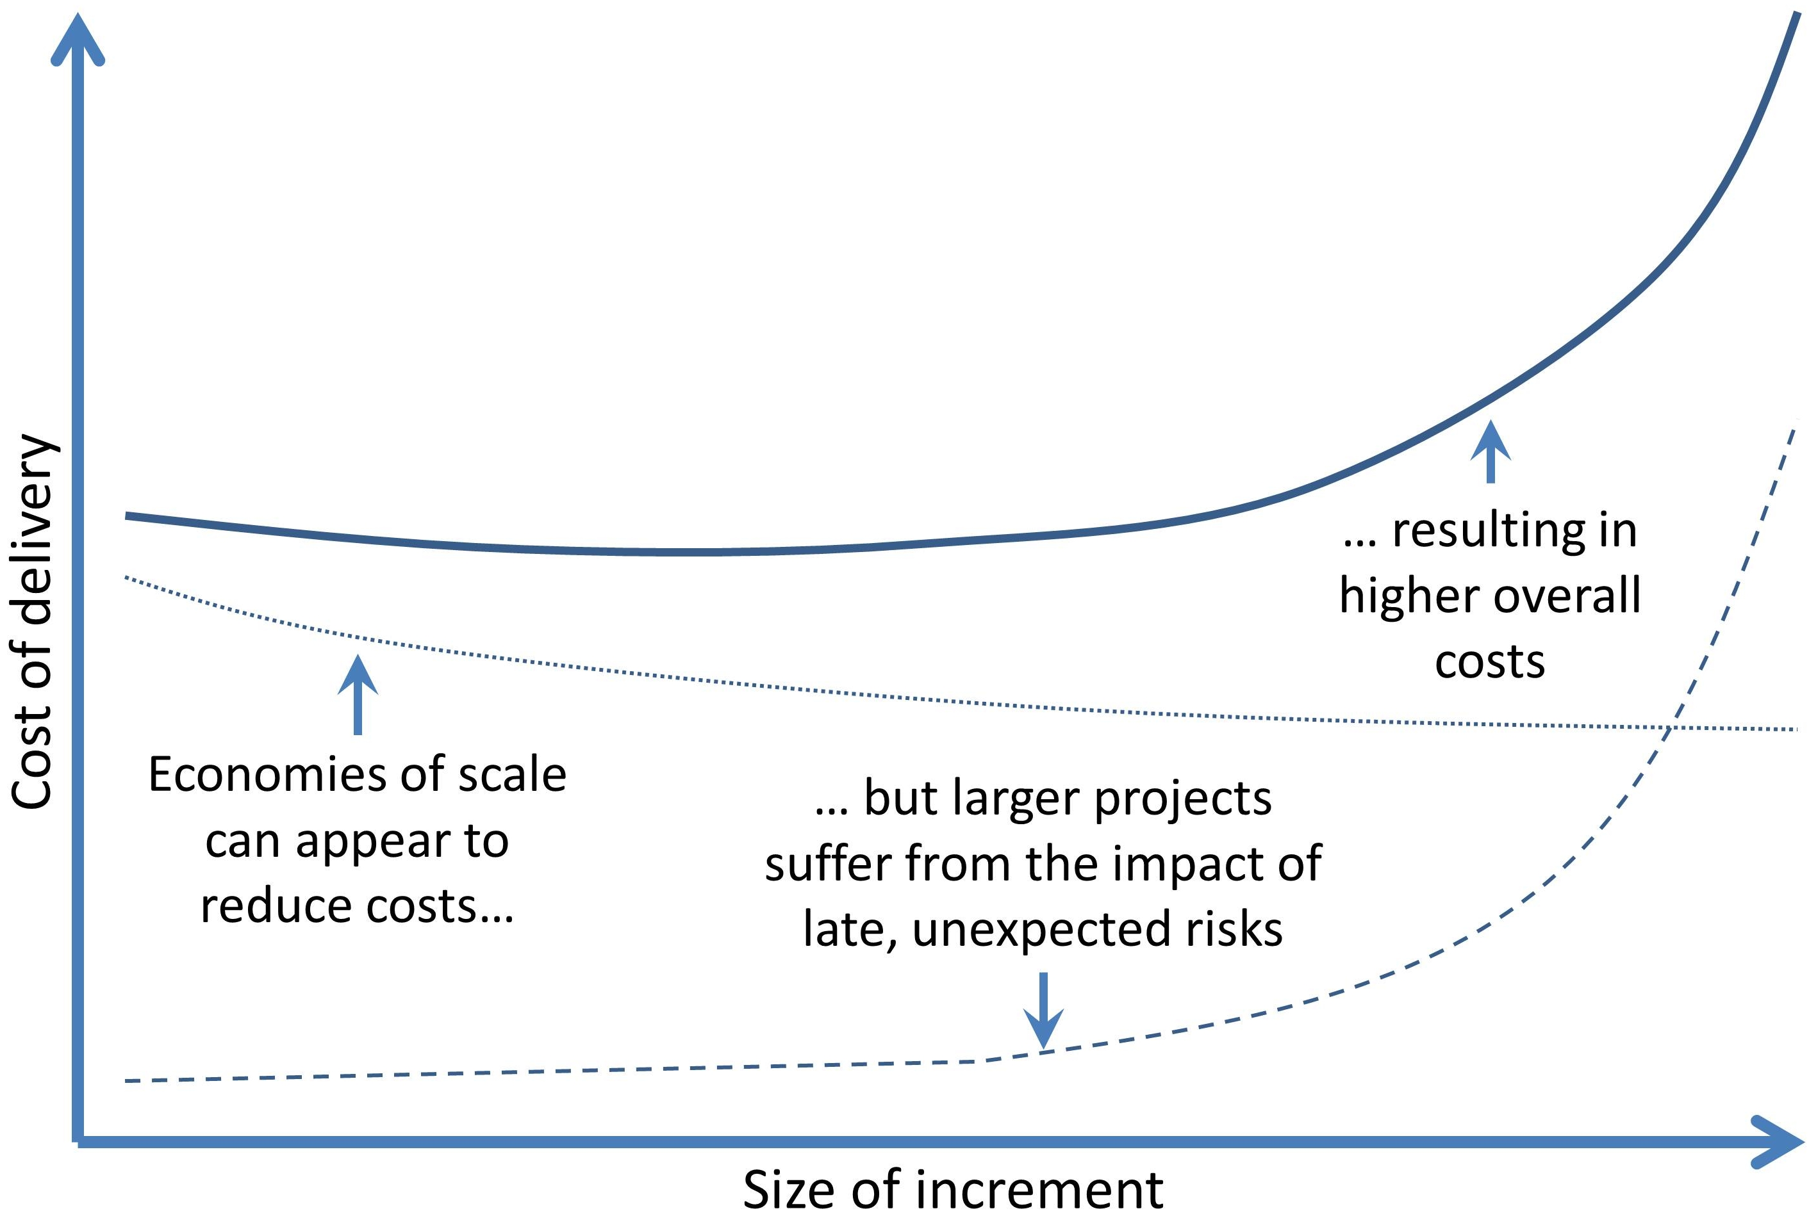

Figure The impact of risk as the time between deliveries increases

Second, notice that the hidden costs of rising risk increase dramatically with size. This is because the importance of a risk depends on two components: the probability of it happening and its impact if it does happen. Larger projects will have risks which are more difficult to predict and they will also have a higher impact if they occur. This is a double-whammy effect that gives rise to an exponential rise in likely cost from hidden risks as project size increases.

Conversely, agile behaviors tend towards doing small chunks of work. Agile projects are smaller, and have lower overall costs – once risk is taken into account.

The more complex the system the more inevitable is change. Typical waterfall approach software projects experience a 25% change in requirements over their life. Larger projects experience a 35% change or more in requirements. Not only this, but the number of these changes is less predictable in large projects. Large projects suffer from more variability in scope than small projects.[4]

Consider waterfall mega-projects: any slight savings achieved through economies of scale are more than wiped out by the costs of counteracting the risks. If management were to consider the risk-weighted costs, a smaller, and more optimum project size would be chosen.

Flyvbjerg attributes the popularity of large projects in the early 2000s to the *mega-projects paradox*:

The irony is that more and more mega-projects are built despite the poor performance record of many projects … The main causes of the mega-projects paradox are the inadequate deliberation about risk and (secondly the) lack of accountability in the project decision-making process.[5]

Efforts to transfer risk to sub-contractors through contractual penalties cannot reflect the true cost of business failure that the client is exposed to – not just additional costs incurred, but the late or non-realization of benefits. Despite efforts to transfer responsibility, the client ultimately must bear and pay for the risk when a mega-project runs into trouble.[6]

Can more layers of assurance help?

One of the first edicts to be proclaimed when the new coalition Government in the UK took office in 2010 was to reverse the decision made in the 1980s which progressively devolved project supervision away from the center of government to individual departments.[7] The Cabinet Office Major Projects Authority (MPA) was established and carried out a review of all large IT contracts. More than 300 IT projects were reviewed with many being put on hold, including the National ID Card project.[8] This initiative was driven by the policy aim of reducing the Government’s public funding deficit. A special focus was placed on IT projects which were perceived to be over-centralized and overlarge.[9]

The reviewers now had a problem – many large projects were underway and needed to continue, and no better alternative for their management had been agreed. Therefore it was decided that a traditional milestone review assurance approach would be used – but this time mandatory and with centralized scrutiny. These improvements in control focused on more detailed budgeting and assurance health checks based on check-box assurance. Some efficiencies were planned by attempting to eliminate duplication of assurance activities through a mandatory Integrated Assurance and Approval Plan (IAAP) for every large project.[10]

This approach to throttling back the size of projects was mainly focused on reducing consultant usage and killing obviously failing projects, such as the £469m Firecontrol fiasco which gets several mentions in this book.[11]. On-going centralized project review was still subject to the same set of Gateway control processes as had been in place for at least 10 years.[12] This waterfall Gateway review approach had failed to stem the number of failing projects, and an agile approach was not explicitly part of the IAAP.

Another problem was the continued reliance on Gateway reports. These reports were confidential between the reviewing team and the project sponsor, and because of their secrecy they could not be requested under the UK Freedom of Information (FOI) legislation.[13]. The original objective of this secrecy was to encourage robust criticism that might have been stifled if embarrassing facts were made public. However, the contents of each report were often widely distributed within the government, so the conclusions were often not clear and were usually overoptimistic. One report stated that the reports were ineffective because of this lack of robustness, and that they were “considered unimportant by Senior Responsible Owners”.[14] One example was leaked onto the Internet in 2011 which contained an optimistic appraisal of a project that went on to fail (see page 145).

Although claiming compatibility with agile approaches, no specific guidance on implementing agile in Government was made[15], and in continuing with ‘more of the same’ the guidance did little to ensure that projects were of optimum size and did not specifically address the following major weaknesses:

* Big-bang delivery is a shock to steady-state operations
* Risks are unquantified and as a result unanalyzable
* The pointless pursuit of certainty through detailed planning
* Solutions being over-specified before the problems they are meant to solve are understood
* The technology being divorced from the stakeholders.

Big-Bang Delivery from Mega-Projects

The big-bang approach is often a side effect of the drive to reduce perceived costs. If all business change is packaged into one delivery on one date this appears to reduce costs – all user training is expected to take place at one time, all testing is planned to be done in one short, sharp phase and therefore development time is saved.

Assuming that big-bang implementation is the best way forward is a convenient simplifying assumption for management and technologists alike. However, with a big-bang approach at the end of a mega-project, the staff members in operations have to suddenly change all their working practices at once and start using a new system, often riddled with bugs and with vital functions missing.

To avoid these risks, many individual organizations, such as the US IRS, and the UK Revenue and Customs, have started to base their change strategies on making changes in increments (albeit in the case of the IRS cases in rather large increments). [16]

But only recently has the UK Government pronounced a ‘presumption against big-bang projects’.[17] And there are three major ways in which big-bang can be avoided:

First, a pilot project can be implemented before committing to national rollout. This can help, but only if the pilot is carefully chosen and there is sufficient time to assess its impact so that the future direction of the project can be influenced. All too often pilots are badly conceived. In the case of the “Pathways to Work” project in the UK the NAO found that:

“The pilot evaluation sampled people who made an enquiry about claiming incapacity benefits – not those who actually went on to claim … and it did not pilot its proposed contractor model.” [18]

Second, phased delivery reduces risk, and the additional costs of phased delivery are usually recouped several times over from earlier delivery of benefits. For example, the UK tax authority, HMRC consulted stakeholders and was congratulated by the NAO for deliberately phasing in the introduction of online business tax returns over a period of three years.[19]

Third, incremental delivery of change can be exploited to reduce the pain and cost of big-bang. An example from India illustrates this problem. The devolution of grant making facilities to Kerala State was sudden and ill-prepared. An audit of the situation by the national audit organization in India (CAG) found that if an incremental approach had been followed, then the problems of training at local levels would have been avoided.[20] Incremental delivery focuses on matching delivery to the capacity of the business for change.

Risks are Unquantified

Projects often drift into being – from an initial concept they rapidly gain a life of their own. One regularly encountered criticism is that investments are committed before enough depth of analysis is complete. The counter-argument is that if one waits for analysis to be completed one would never start work, and nothing would ever get done.

In a recent study claimed to be the most extensive ever undertaken, Flyvbjerg and Budzier analyzed 1,472 projects (of which 92% were public projects). They identified that one in six had cost overruns of over 200%. Moreover, the impact of time overruns of 70% on these projects led to unexpected spectacular losses. These ‘Black swan’ projects included the cargo and flight information system project at the new Hong Kong airport that reportedly cost the economy $600m in lost business in 1998 and 1999. [21]

Detailed best practice guidance on risk quantification for projects has been available for many years. Attempts have been made to raise the profile of governance of project risk, however, project risk management still does not appear on the radar screen of corporate good governance in either the private or public sectors. [22]

Unrealistic Expectations for Certainty

When faced in everyday life with a task that has inherent risks, such as setting out to drive to work when bad weather is forecast, we naturally think of changing our behavior to reduce risk. For example, we might decide to work at home that day, or perhaps set out after the bad weather has passed by. We do not expect to reduce risk by making a list of roads we are travelling on and adding up the exact distances. However, once a direction has been set on a project we all too often see the symptoms of increased analysis and planning as an attempt to reduce risk.

Methods for assessing the inherent risk of the project objectives exist. These methods typically focus on areas perceived to contribute most often to project failure, and then measure the profile of each factor within the project in question. In the UK a Risk Potential Assessment (RPA) form is used to assess major public mega-projects.[23] The recommended response to high risk projects is for the Cabinet Office to apply an extra degree of checking to the project, rather than to work with the project management to change the project approach in order to reduce the inherent risk itself.

The GAO has attempted a strategy of trying to increase large project success through the dissemination of information and best practice. Analysts such as Paul Strassman have noted that despite an accumulation of how-to guides, project success rates have not improved.[24] Over-prescriptive, detailed ‘best practice’ checklists have not helped. Each item on such a checklist seems unobjectionable and logical, but often priorities between these mandatory commandments may be conflicting. Each expansion of a set of best practices adds to the enormous number of rules and stipulations that should be adhered to. Strassman points out that as these rules have expanded, the number of GAO reports detailing information management failures have also increased:

“What GAO misses is exactly what has been at fault with the Government's information management practices. The increasing volumes of congressional diktats, legislative directives, Inspector General guidelines, General Services Administration rules, and departmental standards manuals have not improved performance as systems complexity keeps increasing. GAO has worked the problem from the wrong end. They have tried to induce excellence by adding to an already unmanageable volume of requirements that define best practice and methods … they over define inputs instead of allowing agencies to commit to performance objectives that deliver measurable end-results.”[25]

Solutions Specified Before Problems are Understood

Project managers often make an attempt to head off the twin threats of unknown risks and over-assurance by trying to tie down the requirements too early and in too much detail.

Ironically, such attempts to reduce uncertainty by detailed description of solutions often increase the risk of addressing the wrong problem. The rush to design a solution is compounded by early involvement of specialists with experience in (and an agenda to use) specific technologies, and with a lack of interest in solving the users’ problems. Always using the same staff and suppliers to work on project definition and set-up may seem a low risk approach. But, often this will only tend to repeat the errors of the past, and little fresh thinking will emerge. Overspecification can take three forms:

* First by following Doran’s criteria: objectives should always be Specific, Measurable, Assignable, Realistic and Related to Time (SMART).[26] Too much emphasis can be placed on being ‘Specific’, leading to a branching out of strategic objectives into specific requirements – away from key areas into secondary issues that are not necessary for success.
* Second, detailed requirements often morph too early into designs. Early teachings in structured systems analysis recognized this tendency, and advised against jumping early to conclusions as to the required processes and technologies.[27] In Part II I mentioned the UK Government SSADM method as an example of a waterfall design approach which deliberately split requirements from solutions and *logical analysis* from *physical design*. [28] Such methods became unwieldy as systems became more complex in the 1990s, and these techniques waned. As COTS solutions have become more popular there has been a tendency to assume a particular implementation process or technology and then to write the requirements in terms of what that solution would look like. It is difficult to justify the use of a method that requires extensive ‘logical’ analysis, independent of the probable solution. It can save time to incorporate assumptions as to the technological solution into early requirements analysis, but the risk is that options are not fully explored.
* Finally, specifications can become gold-plated. This most often occurs when there are diverse groups of stakeholders with diverse objectives and their own special methods of working. Without adequate stakeholder management, consultation, prioritization and central adjudication on priorities, a set of requirements can be built up that satisfies everyone but pleases no-one. In the Firecontrol project, cited for different reasons elsewhere in this book, the high-specification regional fire and emergency buildings added greatly to the cost impact of late delivery of the IT system. And that system had been overcomplicated by lack of consensus on core requirements from those running the 46 existing control centers.[29]

The Technology is Divorced from the Stakeholders

Although it may seem obvious that the technologists working on a project should ensure that the solution is closely aligned to the stakeholders’ needs, real engagement and understanding is often lacking.

In 2011 the GAO reported on the cancellation of the NextGen insurance policy and claims management system at FEMA after 7 years and $40m had been spent. Stakeholders had not been involved in requirements gathering and the system did not meet user expectations. FEMA now struggles on with an ineffective 30-year-old system.[30]

Cross-government projects need the support and active engagement of multiple stakeholders across departments and agencies. As mentioned in Part II, ‘ownership’ of a project should not be treated as a simple issue. Usually several parties have to make an investment to make a project feasible, and many projects become unviable because a hierarchy of control has been put in place that does not recognize the need for co-ordination between parties with potentially diverging interests.[31]

Conclusions

The decisions on size and delivery strategies are the most important that can be made when setting up a project. All too often it is enticing to solve all the world’s problems in one fell swoop. Objectives are set out to please the project sponsor without any consideration of priorities or attempt to prune back marginal objectives. By trying to please all the stakeholders the lowest common denominator sets the bar for acceptance of mandatory objectives too low, and the list of requirements becomes bloated.

In large organizations, this tendency can be aggravated by procurement practices that favor large mega-projects. Marginal reductions in overall costs that are gained by organizing work in massive procurements are not matched by the hidden costs of failure. Risks are considered to have been ‘transferred’ to the supplier simply by virtue of huge penalty clauses in contracts for failure to deliver.

However, the risk of not gaining the expected business benefits cannot be transferred – it always remains with the Government, and having over-long periods without any ‘proof of concept’ increases the cost of failure.

In this chapter we have seen how the drive for ever greater economies of scale is based on a flawed economic rationale. Mega-projects that plan for all changes to be implemented as big-bang is a risky approach, and the risks of being large-scale quickly outweigh the savings. Big-bang projects seldom deliver at lowest cost because they tend to delay implementation until everything is ready at the same time. This not only militates against any quick wins, but also escalates risks that would otherwise be manageable. Further, we have discovered the benefits of an evidence-based approach to identifying real-world solutions at an early stage using the discipline of short iterations of delivery. The risks of the Defined Process Approach are reduced by the use of the Empirical Process Approach. Under these circumstances an approach with small iterative steps becomes the optimal.

Questions

1. We started this chapter by introducing the concept of ‘optimum project size’. What is the optimum project size for your current project? Has the hidden cost of risk been assessed in an attempt to moderate project size?
2. What other reasons can you think of for pruning back projects that have very wide, all-encompassing objectives?
3. Think of previous, successful projects you have worked on. What aspects of PDSA iterative development were exhibited?
4. Look at the IAAP diagram that the UK Cabinet Office has published (see Endnote [32]). Make a list of the positive and negative aspects of the project life cycle it assumes. Is this model suitable for reviewing agile projects?

1. {Standish Group 1995 #17}
2. {Victorian Ombudsman Nov 2011 #18}
3. What size constitutes a mega-project? Davies uses a rule of thumb of £1bn for construction projects. If we assume that it is the value of the intellectual effort of planning and design that relates to risk, not the cost of concrete and steel, then a size of £50m – £100m for IT projects might be indicated as being *mega-projects*. {Davies 2009 #109: 18}.
4. {Proceedings of the 31st EUROMICRO 2005 #392: 4}
5. {Flyvbjerg 2002 #111: 6}
6. {Davies 2009 #109: 19}
7. {Joe Organ 2003 #10}
8. {No stone unturned #3}
9. {Office 31/03/2011 #4: 2}
10. {UK Cabinet Office 2011 #5}
11. {NAO 2011 #206: 4}
12. {Best Management Practice BMP Portfolio #7}
13. {Agile for Universal Credit 2011 #388}
14. {Collins 2012 #337}
15. {Cabinet Office 24/06/2009 #8: 1}
16. {IT Modernization Vision & Strategy 2007 #236}
17. {Public Administration Select Committee PASC Wednesday 30 March 2011 #13}
18. {NAO May 2010 #14: 6, 25}
19. {NAO Report HC 930 2007-08 July 2008 #15: 11}
20. {Comptroller and Auditor General (India) 2004 #16}
21. {Flyvbjerg 2011 #19}
22. {UK Cabinet Office (OGC) 2010 #20}, {UK Association for Project Management 2011 #23}, {FRC 2005 #22}, and {NAO 2010 #21}
23. {UK – Cabinet Office #24}
24. {Strassmann 1997 #174}
25. {Strassmann 1997 #174: 142–144}
26. {Doran 1981 #30}
27. {Gane 1977 #31}
28. {Longworth 1986 #32}
29. {NAO 2011 #206: 27}
30. {U.S. Government Accountability Office 09/06/2011 #38: Summary}
31. {UK Association for Project Management 2007 #39}
32. {UK Cabinet Office 2011 #5: 11}