## AGLPM5 – Unit 3 - ACTIVITY 2: OBSERVE

***Addiction to Process***

This document is an excerpt from the book:

“Agile Project Management for Government “

Authored by Brian Werham

Published by Maitland & Strong

Reproduced with permission under license



PMCAMPUS.com / Mokanova Inc

.

© 2003-2016 Mokanova Inc and its licensors. All rights reserved for all countries. PMCAMPUS.com is a trademark and service of Mokanova Inc.

PMI, PMBOK, PMP are owned and registered marks of the Project Management Institute, Inc.

## Single use only. Do not download, print, duplicate, and share

Addiction to Process

A well-functioning team of great individuals with mediocre tools will always outperform a dysfunctional team of mediocre individuals with great tools.[1]

Mike Cohn  
founder of Mountain Goat Software

Organizational development should stress the importance of people and leadership, not a constricting process model. If the leaders of the organization see process as the primary driver of culture change, then the resulting culture will value process over people – the opposite of the approach called for in the Agile Manifesto. Elizabeth Thomas has branded this reliance on documented procedures as an ‘addiction to process’ – an addiction that agile can help break.[2]

However, commentators such as Rakitin have articulated concerns about the intent and the impact of the Agile Manifesto:

“(Not) using a process gives (hackers) the freedom to do whatever (they) want – spend all (their) time coding – (these) programmers don’t write documentation – (they) work out the details once (they) deliver something. On-going design at development time … has become an excuse for putting off design until the last minute … a disaster in the making for larger (projects) – planning as something you can do on the fly … is a recipe for disaster on projects of any significance.” [3]

His main objections are based on the possibility that some will see the Manifesto as a license to ignore the ‘items on the right’ (see page 60). Processes and tools, documentation, contracts, and plans still have their place, even on an agile project. The Manifesto clearly states that a balance is required between the practical and the theoretical elements of planning and execution. When in doubt, it suggests, the presumption should be in favor of, say ‘*individuals*’ over ‘*processes*’. I propose that the most effective way of countering the dangers of anarchy that Rakitin warns about, is not to rely on the use of agile best practice alone (although that has value), but to ensure a focus on agile leadership.

As we have seen, the Agile Manifesto Principles provide an underpinning that moves the manifesto from being a statement of intent, to a concrete influence of team process. By encouraging business and technical people to work together, trust is engendered and inefficient communication is reduced. Motivation is increased because, as the solution emerges, it is continually tested, improved, and demonstrated to be working. Rather than a desperate run towards a long distant milestone, a baton relay in stage at a fast, but measured pace is encouraged.

Decisions should be delegated to the lowest appropriate level, thus reducing the risk that the project will go off track.

The Apparent Paradoxes in Agile Processes

The Agile Manifesto exhibits four features, which on first glance appear to be paradoxes:

* Tight control over the overall project, but a light touch when it comes to giving direction to a team
* De-emphasis on documentation but a high value on comprehensive, thorough testing with detailed audit logs
* Lack of written process within the team, but a stress on rich and immediate communications

Informal liaison, often unseen, across disciplines and organizational units, but high transparency of the plans and actual progress.

It is the perception of paradoxes in the agile manifesto that have been identified as the main inhibitor to uptake – both in commerce and the public sector. Agile processes are not plan driven but instead drive the refinement of a plan. Realistic, detailed plans exist for short-term activities, but plans further out into the future are more in overview, and all plans are subject to revision.[4]

Agile processes are self-managed rather than imposed. Communication is not channeled through a hierarchy, but directly between team members and those that they need to speak to. This requires senior management to relinquish aspects of detailed control. They must recognize that team members are usually in a better position to make detailed business and engineering decisions than they are.

Agile Organizations

Sridhar Nerur argues for a shift from command-and-control in organizations to leadership-and-collaboration. The project manager’s traditional role of planner and controller must change to one of facilitator and coordinator. Organizations must accept that not all detailed knowledge can be codified and documented – Agile cuts down on the overhead of bureaucracy, reducing documentation.[5]

Authoritarian project management needs to be replaced by a cooperative social process of communication and collaboration. Many technical experts are accustomed to solitary activities and many failed projects have allowed development teams to work apart from business people.[6]

However, the perception propagated by some enthusiasts that only above-average people can use agile is self-defeating. If agile can only be used by an elite, then skills shortages and the dangers of exclusivity may affect morale of non-agile developers and create barriers to adoption. [7]

New ways of expressing the effectiveness of processes in an organization are needed. Especially those that encourage flexing of the processes to fit the capabilities and competencies of people and the characteristics of each project. [8]

Light-Tight Governance Enables Agile Approaches

Davies and Gray contend that conventional management of change tends to be light at top management level, but that, conversely, individual projects tend to be tightly controlled. They call for this conventional wisdom to be turned on its head. They argue that exactly the opposite approach is required for success: tight management at the top level to achieve a highly consistent approach across a broad program of work, whereas other aspects are lightly managed to provide flexibility.[9]

Agile can provide a framework for introducing this *light-tight* management. For example, DSDM specifically differentiates between tightly directed teams and those that are *self-directed*. Self-directed teams develop rich communications channels and are able to demonstrate the evolving solution in shorter increments – there simply is not enough time to control fast-moving teams with a bureaucratic process. These teams take initiative rather than directions.[10]

Effective organizations exhibit *tightness* at top management level by ensuring consistency in the control of the company-wide portfolio of projects. For example, when combining reports from many sub-projects up to the larger portfolio level or when there is a need to reinforce some specific organization-wide objective.

And these effective organizations exhibit *lightness* in control of the detail of the work of teams. Where the implementation of overall targets (for example, health and safety) can be achieved in many different ways, each project team in these organizations is individually responsible for the specifics of how these should be achieved. Imposition of standard approaches will be counterproductive – it is better to provide an objective, and encourage each team to find their own route.[11]

So, organizations that are effective at governing their projects use *light-tight* leadership behaviors. However, the three other, dysfunctional combinations (*light-light*, and *tight-tight*, and *tight-light* governance) occur frequently, and are usually present when large projects break down and fail (see Figure 1).

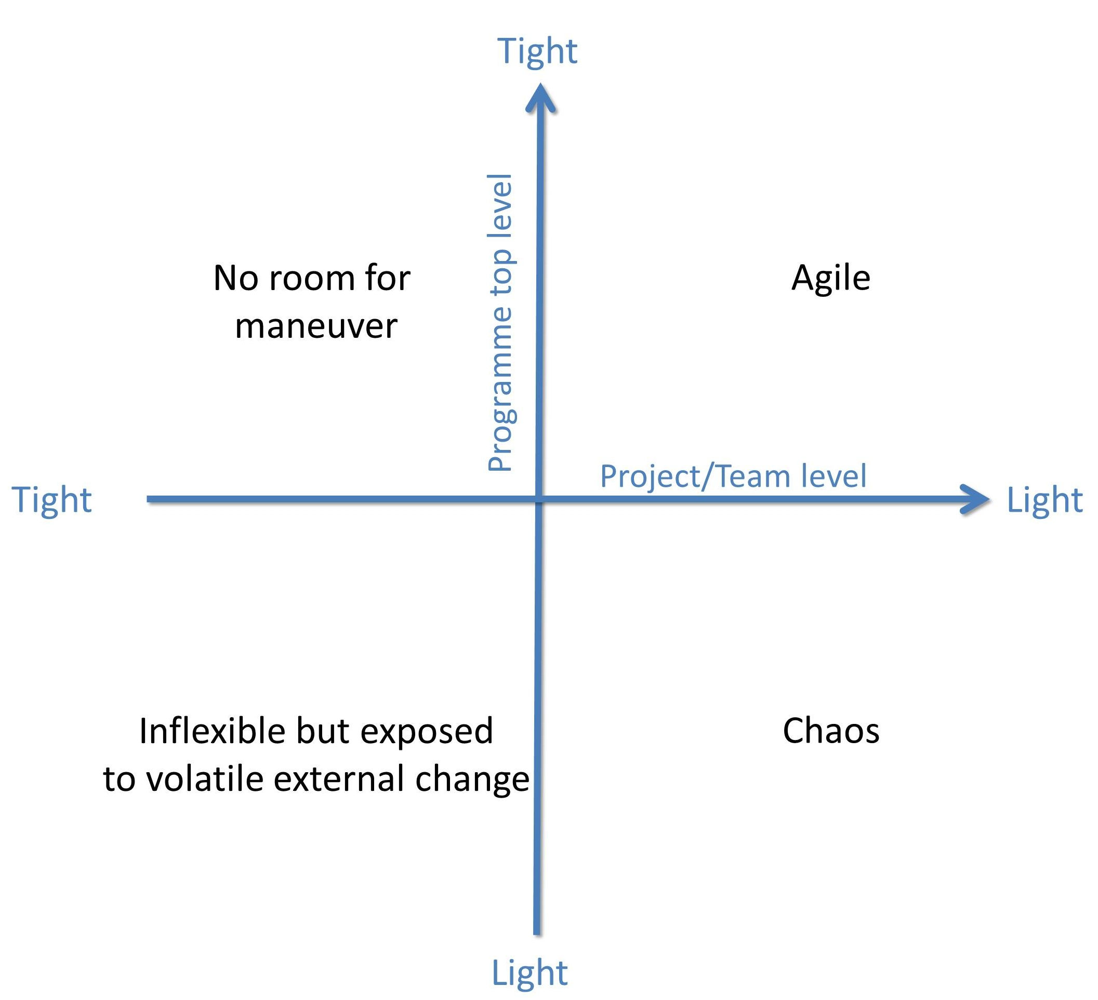

Figure : The dimensions of control

Chaos: the Light-Light Model of Control

Projects often come into being without a conscious decision to get organized and are passed from one top manager to another until they find a comfortable home. These are typified by a combination of inconsistent leadership coupled with an ad-hoc approach to planning. These projects fall into the category of *light-light* control. In the early stages of a project when requirements are starting to emerge, the business case is unclear and often only top management is involved in discussions on alternative solutions, and do not involve their staff. *Lightness* is evident at all levels. Often there is only a small team working on the project at first, usually at ‘policy’ level. Control of these small research teams seems simple enough, and often projects go through initial stages of work and start to grow before top management considers bringing some discipline and structure to the governance of the project. One government review in Canada found this to be a factor in underperformance and failure resulting in:[12]

* Project conception that results in unwise approaches
* Unsupportive project environments that contain barriers to success
* Project participants who lack the necessary qualifications or experience.

The approach to be taken on a project is often decided upon before a governance structure has been agreed, and in many cases the business case is an after-thought. In the case of the UK Government’s Work Programme the NAO found that:

“The Department (for Work and Pensions) devised the business case for the Work Programme after the main decisions had been made and before data about the performance of existing projects was available. No alternatives were considered.” [13]

In the UK and Canada, a gated review approach is now in place to try to create a tight approach to governance for all large projects.[14] The problem in the past has been that reviews have been carried out too late to improve project start-up. A major review across UK government projects found that a major risk was from projects entering the process after the business case has been prepared in the first of a series of pre-defined decision *Gates*. Most (63%) of project boards never bothered with a business case Gate Review, and a sizable minority (41%) did not review at the next Gate (Delivery Strategy) either.[15]

Inflexibility: the Tight-Tight Model of Control

Organizations that have experienced the chaos of light-light control sometimes react by moving to the polar opposite: *tight* controls at every level when managing change. One means of attempting this focus on process is by using the Capability Maturity Model Integration (CMMI®) model.

The CMMI model is based on approaches to continual improvement of processes by Crosby, Deming, Juran, and Humphrey. The main assumption in the CMMI model is that “the quality of a system or product is highly influenced by the quality of the process used to develop and maintain it”.[16] It is claimed by many, including the US GAO, to contain the essential elements of effective processes and enables the user of the model to measure the degree of *maturity* in processes involved in governance of projects and technical development (see Table 1).[17]

Table : CMMI Maturity Levels[18]

|  |  |
| --- | --- |
| **Level** | **Maturity Level** |
| 1 | Initial |
| 2 | Managed |
| 3 | Defined |
| 4 | Quantitatively Managed |
| 5 | Optimized |

The UK Department of Work and Pensions (DWP) has placed a great deal of emphasis on its adoption of the CMMI model, becoming officially accredited in 2008.[19] However, this ‘improvement’ in internal IT procedures did not help its operations to reduce error and fraud. Mistakes made by staff processing benefits in FY 2011 remained critically high at estimated £1.1bn in overpayment and £500m that should have been paid to the needy was not.[20] Problems with its IT projects continued with high profile projects such as ASD being cancelled (see page 145) and the Work Programme IT system leaving the department open to a £60m risk of fraud. DWP remains the only UK central government department with qualified financial accounts. [21]

In 2011 the US GAO issued no less than 10 reports that used the CMMI process model as a reference for measuring the ‘maturity’ of organizations.[22] Although they repeatedly note in these reports that the CMMI model is “highly regarded and widely used guidance, they do not provide any evidence base to justify it as a driver for efficiency and effective processes.6 In their own recent report on the critical factors underlying successful major acquisitions, they admit that after more than a decade of increasing volumes of best practice guidance, legislation, and increasing calls for CMMI compliance:

“IT projects (still) too frequently incur cost overruns and schedule slippages while contributing little to mission-related outcomes” [23]

The very existence to CMMI accreditation has caused problems. In one case the winning bidder for a NASA contract for ground systems and mission operations services lodged an appeal with GAO against the award of the contract to another bidder on the basis that it did not have the CMMI accreditation, even though it was not a requirement of the procurement.[24]

The US IRS has implemented CMMI, with a massive resultant increase in overheads. A recent GAO report noted that the IRS was now spending $174m (15% of its program budget) on support activities to run these procedures. A much higher proportion than is normal for a federal department, and yet the GAO could not link this spend to any specific improvements in output. Problems still remained, including:

* One project that was 70% over cost due to unplanned requirements
* Weaknesses in information security
* Over-optimistic plans for the new mission-critical CADE2 tax records system

Poor tracking of overhead spending, with over 50% of the bureaucratic overheads of running CMMI itself being mis‑categorized. [25]

Michael Spayd, a former CMMI assessor stresses the cultural misfit between the agile approach and the process maturity mind-set:

“It's certainly true that culturally speaking, CMMI lives most easily in a control culture, where the idea is really to minimize risk by emphasizing predictable, repeatable results” [26]

Theoretically, Spayd says, it is possible to implement CMMI without using the waterfall approach or BDUF. But most organizations take a process-driven route to CMMI achievement without any nuance. In most cases it simply reinforces a waterfall culture, rather than helping it to become agile.[27]

The latest research from Forrester shows that CMMI take-up is reducing, and that most respondents firmly place CMMI in the same category with waterfall techniques, with only 13% pursuing that model.[28] Many organizations start up the CMMI mountain, but very few stay balanced at the top, in an optimum position There are four reasons why so many problems exist for the adopters of the CMMI model in government (see Figure 2). These are: [29]

* It is difficult for many organizations to make the necessary investment up-front to develop and document effective processes if the returns are not immediate and obvious.
* Although many organizations have reached CMMI level 3 (of managed processes), CMMI level 4 is a potential *vale of despondency*. More processes become documented, and yet more quantitative measurement takes place. However, this produces little benefit until the processes start to become optimized, which is meant to happen at level 5.
* Organizations find it difficult to optimize, and the process of ‘becoming mature’ may overshoot. The rollout of CMMI project can push the organization over into what I call “CMMI level 5½”, where processes are over‑documented, over-measured, too broadly prescriptive and difficult and expensive to change. Finding the sweet spot of CMMI can often turn into an expensive and forlorn search for the holy grail of CMMI level 5.

Any great investment in organizational maturity is at risk from organizational changes which split or join together portions of different departments. Organizations which are highly dependent on process maturity tend to have brittle and inflexible responses to organizational changes that are thrust upon them.

We saw in Part II that Microsoft had decided only to implement *just enough* process in their development of the Government Gateway – they had decided not to try and implement CMMI level 5 for this very reason.[30]

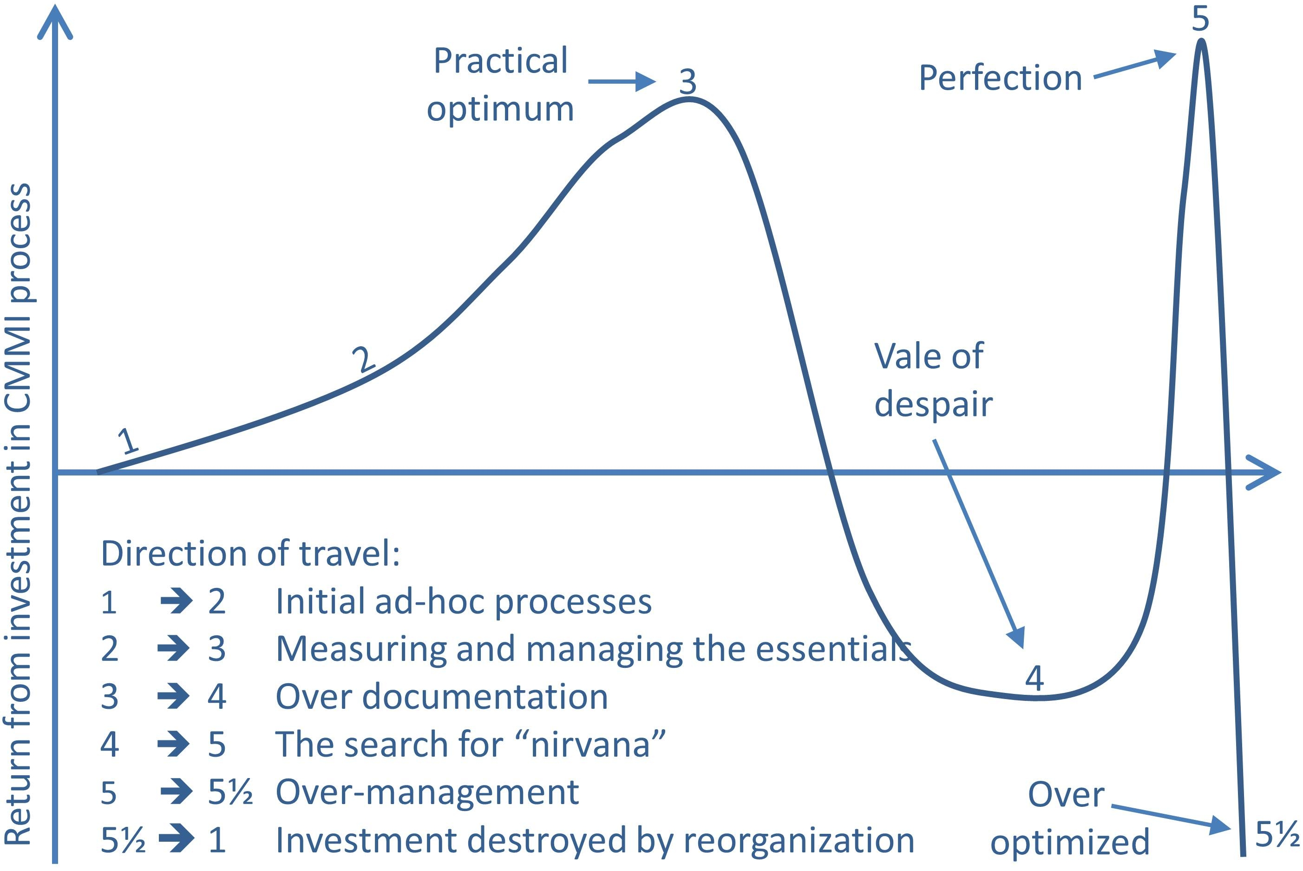

Figure : Problems with CMMI *overmaturity*

An example of over addiction to process at the expense of efficiency was the failure of phase two of the Sentinel project which was salvaged eventually by the adoption of an agile approach. The then Chief Technology Officer, Jerome Israel, still feels that the process was right, they just didn’t have enough of it:

“The FBI’s engineering strength was weak—we didn’t have the engineering talent to pull off a major project like Sentinel … (So) how can government agencies assure Congress that taxpayers’ IT investments will be successful? … If the DOD rates software development companies according to CMMI, why not apply a similar model to government agencies?” [31]

Spayd rejects this argument:

“There's a fundamental assumption in the CMMI that processes can be repeatable, and that they are predictive processes, basically not empirical processes. That is the fundamental flaw in the CMMI, and that's actually why I don't personally believe in level 4 and 5. They are ridiculous and do not create value.” [32]

And a further weakness of the CMMI approach is that unexpected reorganizations become difficult and very expensive in process-bound organizations, as the NAO recently pointed out:

“There have been over 90 reorganizations (in) central government departments … between May 2005 and June 2009: over 20 a year on average. We estimate the gross cost of the 51 reorganizations covered by our survey to be £780m, equivalent to £15m for each reorganization and just under £200m a year. Around 85% of the total cost is for establishing and reorganizing arm’s length bodies. (Staff and information technology cost £473m).” [33]

Turner and Jain examined whether a partial implementation of CMMI could work alongside the agile approach. They consulted with both CMMI proponents and agilists. They found that the CMMI experts could be sub-categorized into a *conservative, by-the-letter group* and a *liberal, concepts oriented group*. They also found *conservative agilists,* who were extremely rigid in their definitions, and *liberal agilists* who saw value in comparing, matching and hybridizing methods. The conservative sections on either side of the argument found little to agree upon, and divided into two separate camps. However, the liberal groupings generally agreed that there were some components of CMMI that supported and complemented agile (see Table 2).[34]

Table : Components of CMMI and their possible support of agile[35]

|  |  |
| --- | --- |
| **CMMI elements that  may conflict with agile** | **CMMI elements  that may support agile** |
| Objectively  Evaluate Adherence | Ensure Continuous  Process Improvement |
| Collect  Improvement Information | Manage Configurations |
| Stabilize  Sub-process Performance | Train People |
| Establish Quantitative Objectives for the Process | Provide Resources |
| Plan the Process | Identify and Involve  Relevant Stakeholders |
|  | Assign  Responsibility |

The four CMMI elements that most agile proponents found most difficult to see as agile-friendly were those that most ‘tightly’ controlled the detailed work of developers through documented process. All the agilists disliked the idea of a “process mafia that checked on how the developers developed”. They felt that it would be expensive and distracting if detailed processes not associated with customer objectives were recorded and analyzed. On the other hand, the agilists were split over whether defined processes for continuous improvement, rigor in configuration management, and up-front planning were, or were not anti-patterns to the agile approach. Overall the researchers concluded that:

“It is evident that while there are significant differences, the ‘oil and water’ description of CMMI and agile approaches is somewhat overstated … It is our belief that there is much in common between the two world views, and that the strengths and weaknesses are often complimentary.” [36]

A recent example of *tight-tight* project management in the UK Child Maintenance and Enforcement Commission (CMEC) within the Department of Work and Pensions (DWP) led to the abandonment of an agile approach on a critical project.

The track record of IT systems implementation at CMEC and its predecessors was appalling. CMEC was set up to take over the work of the Child Support Agency whose IT systems were grossly inaccurate. CMEC’s job was to track down absent parents, enforce child maintenance payments and pass these on to the responsible parents. A new database was built to address this problem but it was scrapped when it could not take on the data from the old system. Then a third system was developed, but it was so poor that an extra 600 staff had to be taken on, at an annual cost of £43m to manually handle claims that the new system still could not process.

So, a fourth system was planned. Costs on the project rose from £149m to £275m and the incremental approach that was promised was abandoned. Two key factors were at play:[37]

* Management planned a big-bang delivery of all functions of the new system from April 2010. As with so many big-bang projects, the management realized after a time that full implementation all at once was unrealistic, and belatedly (and at some expense and further delay) decided to change to a phased implementation.
* The project approach was inconsistent and unintegrated. One team worked using a requirements list and followed a traditional waterfall approach. A second team used the JAD approach (discussed earlier in Part II) that they claimed was agile to develop extensive prototypes. The two teams worked in isolation. Two sets of overlapping, conflicting and ambiguous specifications were constructed. (One source claims that over the 90,000 requirements were documented.) [38]

Another recent major IT project within DWP also had significant delays caused by ‘tight-tight’ project management in a CMMI environment. A major IT system was required in 2011 to make £1bn a year payments to suppliers to the new “Work Programme” applying automatic safeguards against fraud and error. However, DWP delayed work from starting until it decided on a detailed BDUF specification.[39] Delivery of the complete system was then planned in one big-bang for autumn 2012, leaving large amounts of money subject to the possibility of fraud and error (at least £60m by March 2012, rising by £20m for each month of delay).[40] DWP decided, again belatedly, to split implementation into more manageable portions: the error and fraud functions earlier and the management information and reporting functions later.[41]

Inflexibility: the ‘Tight-Light’ Model of Control

Some commentators have wryly commented on enforced implementation of management processes as *anti-patterns* of inefficiency – that is, processes that actually worked to increase risk and decrease efficiency. Michael Finkelstein, tongue in cheek, even proposed levels of ‘immaturity’ (see Table 3).

Table : Finkelstein’s irreverent suggestion for measuring ‘immaturity’ levels[42]

|  |  |  |
| --- | --- | --- |
| **Level** | **Immaturity Level** | **Characteristic** |
| Zero | Foolish | Negligence |
| Minus 1 | Stupid | Obstructive |
| Minus 2 | Lunatic | Contemptuous |

This effect can be perceived in large organizations that attempt to control the detailed work of teams without attending to deficiencies in management control and organizational behavior.

“All immature organizations (in contrast to Level 1 organizations) fail to recognize that their management is severely awry. They believe firmly that a technical fix will solve all their problems. For these organizations management issues almost never appear at the top of key priority issue lists.” [43]

At *level zero*, Finkelstein suggests, organizations subvert attempts at the individual and team levels to work together to be productive. Lightness in management attention will result in ill-informed and badly thought through decisions. Top management may change implementation plans and pull the rug from under the feet of the solution development team.

At *level minus one* the organization actually works against productivity. Finkelstein says that they may “sincerely believe that they are assisting”, but the result is obstruction – solutions are actually prevented from being developed, let alone implemented.

At *level minus two*, the obstructions are so systemic that they can only be the result of cynical manipulation so as to increase the cost of development and maintenance through development inefficiencies and solution unreliability.

Although Finkelstein was not proposing a serious analysis, the paper itself simply reflects a presumption that process maturity is a ‘good thing’ and that those adopting a different stance are deliberately being obstructive. However, researchers on organization change have suggested that what appear to be destructive behaviors of those obstructing change, are actually adoptions of alternative models of behavior that make sense to those exhibiting them. In other words one person’s ‘pattern’ may simply be another person’s ‘anti-pattern’, and vice-versa.[44]

Agile: a Light-Tight Control Model for Success

In the early stages of a project when the business case is developing, top management must exercise self-discipline, especially when solutions are beginning to emerge. Attempting to put in place appropriate decision-making structures after a project has already started creates unnecessary risks.

Options for the intended solution may have narrowed down to just one approach. This often results in a business case that merely attempts to justify a pre-ordained decision, and fails to explore other options. These other options may be revived later in the process when the preferred approach proves problematical. If some of the assumptions in the intended approach are flawed, and problems are encountered when building a solution, or feedback from testing and piloting is negative, then some of the previously discarded options may need to be revived.

Similarly, the development route to be taken, for example whether to use a COTS solution or build a new solution from scratch, should be analyzed and any assumptions carefully tested and revisited as the project progresses.

Early adoption of ‘tight’ top management processes will help set up a project environment that enables, not constrains teams, and the necessary skills can be brought to bear on the problem through thoughtful appointments and appropriate procurement of suppliers.

The use of a gated review approach is useful, but it is in the early stages pre-business case and pre-procurement that benefits are greatest. Late, heavy-handed use of gated reviews to fix poor strategic decisions by imposing detailed management processes on solution development teams will simply result in further entrenchment of ‘light-tight’ controls.

Certain aspects of process approaches, such as CMMI, may support an agile approach – especially those that help management proactively work to support the development team to success, rather than strangle them with inappropriate red tape. The two mistakes that are most likely to risk the objectives of *light-tight* control when implementing CMMI are unthinking adherence to process, and inappropriate measurement of team effectiveness.

As we saw on page 190, agile approaches do produce useful metrics that help track progress and improve productivity. There are claims that these measures can be successfully adopted within a CMMI and EVA approach without endangering the maturity level of overall management process, and without imposing a non-agile approach on the development team.

Most importantly, top management must be careful not to believe that technical decisions can fix strategic problems. Changes to requirements can and will happen and should be embraced and exploited by solution developers. Inflexible and expensive change control procedures can slow down the adoption of necessary changes, and make that those changes late, expensive, and painful.

Curing the Addiction to Process in the US

In this section I will outline the claims for agile success made in the first year after the Vivek Kundra’s 25 Point Plan was published. The plan itself was intended to *“*shock the system*”,* and shake up the counterproductive processes that had led to so many project failures. This attempt to cure the government bodies of their addiction to process kicked off with several major initiatives to put in place technologies that complement agile approaches. These included:[45]

* Cloud Computing: an approach to buying and running IT services that allows the customer to immediately and incrementally purchase extra capacity, or slim down usage as demand changes, without the need for long, drawn out projects or procurements.
* Shared Services: centralizing IT databases and standardizing on run-of-the-mill business processes, such as personnel management, purchasing, invoicing and accounting. This does not just save money, but also focuses IT development on value-added projects, rather than catering for unnecessary variations in local practices.
* Upgrading project management skills: Introducing innovative approaches, including agile, by the creation of a new IT project management career path. Breaking down barriers to adoption of agile by requiring integrated project teams, rather than silos of specialties and by collaboration on creation of best practice guidance.
* Aligning the acquisition/procurement process to IT life cycles: making sure that specialized IT acquisition professionals can support agile approaches, and facilitate the use of small, innovative technology suppliers.
* Influencing Congress: aim to change legislative frameworks that are ‘anti-patterns’ to agile development.
* Restructuring the Investment Review Boards (IRBs) to implement the “TechStat” project review model. Kundra criticized the previous approach as follows:

“Many current IT projects are scheduled to produce the first deliverables years after work begins … (because) projects designed to deliver initial functionality after several years of planning are inevitably doomed … typical IRB meeting agendas currently set aside two hours to review the entire IT portfolio, far too little time to adequately review dozens of technical projects.” [46]

The UK Also Starts to Quit Addiction to Process

In 2011 the UK Coalition Government published its IT Strategy. The UK focus was similar to the US 25 Point Plan: to reduce costs and to increase flexibility in public services. The plan was greatly influenced by the Institute for Government whose 2011 report, “System Error”, had recommended two major changes:

* First, the adoption of the concept of *government as a platform*, by the creation of a shared, government-wide approach to driving down costs and increased interoperability
* Second, the rollout of agile project management throughout government.[47]

The IT Strategy planned 19 separate strands of technological change, one of which was the adoption of an agile approach. The Government announced plans to use flexible framework contracts, rather than the large fixed price contracts that had so often ended up as anything but fixed in price and length. It was perceived that the tendency for massive contracts favored an oligopoly of large suppliers. A target was set for 50% of all large IT developments to be running using agile techniques by 2013.[48]

In 2011, in the very early stages of the implementation of the new UK Government IT Strategy, the NAO investigated the planning and set-up activities. Their report was optimistic, but found that there were no clear measurable targets in the strategy and no system to measure its impact. They warned that because there was no overall plan to support the strategy, progress could be hindered through lack of resources.[49]

However, one year later there was still little evidence of the promised increase in use of agile approaches. 10 departments had not yet started any significant agile projects, and in those that had, agile adoption was patchy. Significant progress was reported in only three areas:

* The massive Universal Credit project was underway using some agile techniques
* The Government Digital Service had released alpha.gov and beta.gov websites (as discussed on page 194)
* Significant training of staff in agile had been carried out at the Maritime and Coastguard Agency.

When the Government produced a statement on progress towards the IT Strategy in June 2012, the only agile project cited as a success was the successful, but small-scale, e-Petitions project which, although it had collated 16,000 petitions successfully, was not a large-scale delivery project.[50] In a response to that statement, the IFG published a report from their research into progress. They interviewed all significant Government CIOs and their procurements staff, and representatives of IT suppliers – both large and small. They found that progress towards using agile approaches has been slow.[51]

They noted that the US has effective direct intervention from a strong Government Chief Information Officer (CIO). In the UK they found that the implementation of agile and the strategy overall was poorly coordinated, incoherent and still without clear objectives or success criteria, despite the warnings in the NAO report of the previous year. The IFG noted that although senior leaders in government and in technology suppliers supported the concepts proposed in the 19 strands of the strategy, they were not convinced about the approach to implementing it:

“The IT strategy did not … adopt the (previous IFG)recommendation that ‘platform’ and ‘agile’ should be driven by a strong, independent CIO – instead (it relies on a) CIO delivery board. CIOs should question whether they are genuinely improving the ways that they are working in areas such as agile, or whether they are just attaching a label to projects to get a tick in the box.” [52]

The IFG found that there were concerns that the agile projects that were underway were “often very minor projects running on the fringe of the departments” and that “in some areas projects may be being labeled as agile without having really changed the way in which they were run.” [53]

Large and Complicated Processes

A strand of the UK strategy that crucially depended on agile adoption was the drive to achieve greater efficiencies through the economies of scale of Shared Service Centers. Several of these had been set up by the previous administration to provide centralized services to Government departments to reap massive economies of scale.

However, rather than buying simple accounting software and implementing their new business model in an incremental, phased and agile manner, these shared services were set up using a waterfall mentality. They bought huge, complex systems that would take years to bed in. The Enterprise Resource Planning (*ERP*) systems they purchased from SAP and Oracle were meant to be set-up by non-programmers by the alteration of look-up tables and parameters. However, experience shows that this work has always been fraught with difficulty. They took a substantial amount of effort and skill to set-up, and came with unexpected difficulties. Their “tremendous generality and enormous complexity” make them prone to “glitches and low performance”. Not only are they often “nightmarish to implement” but also “difficult to maintain”.[54]

Potentially these ERP systems can bring about efficiencies, but their complexity encourages unnecessary customization. Standardization is difficult to achieve unless led from the top:

“A thirst for customized software and a lack of mandation means seven years on, shared services aren't delivering value for money … the cost to establish, maintain and upgrade these systems is high. … two centers now intend to totally­­­ re-implement their existing systems with simpler, standard software, despite the significant investment already made … it is not clear why such expensive solutions were bought. Other smaller and simpler accounting packages were not looked at to see if they may have provided the required functionality" [55]

The spectacular AU$1.2bn failure in 2010 of a botched big-bang payroll implementation by IBM in Australia at Queensland Health is an example of these problems, and contrasts with the agile successes in other departments elsewhere in the State of Queensland documented in Part I of the book. The new payroll project was based on the SAP COTS package and was implemented using a waterfall approach, based on formal change control of an inadequate BDUF. Parallel runs against the old system were not carried out and it went live in a big-bang fashion. The government had to make emergency loans to thousands of staff left unpaid in the months after implementation. Two years later overpayments still affected nearly all of the 78,000 staff, requiring 200,000 payment adjustment entries to be applied manually every month.[56]

Conclusions

This book argues that management control and agile are not incompatible. Some proponents of process maturity argue for *tight-tight* control – tightly defined processes for management and tightly defined processes for development. Some proponents of agile place themselves at the extreme end of both spectrums. They wish to divorce themselves from management control completely: a *light-light* model. But this model could be a dangerous road to chaos.

The agile approach provides a successful model of *light-tight* management which offers the best of both worlds: enough freedom being given to the development team and its expert abilities, combined with effective engagement with corporate governance.

Questions

1. Which aspects of your organization’s management process maturity enable or inhibit your project’s effectiveness?
2. Which patterns of behavior in your current work do you see around you as negative ‘anti-patterns’? Imagine how these behaviors could be perceived as constructive and useful from a different perspective.
3. How was your current work initiated? Is there a business case? When was it drawn up? Were alternative options considered? Has it been reviewed and fine-tuned since?
4. The incoming administrations in both the US and the UK wanted to cure their respective government departments and agencies of ineffective addiction to process. Compare and contrast the TechStat approach (see Endnote [57]) with the Delivery Council approach used in the UK (see Endnote [58]).

1. {Cohn 2005 #1: 21}
2. {Thomas 2011 #241: 8}
3. {Glass 2001 #136}
4. {Wang #135}
5. {Nerur 2005 #138: 74}
6. {Beath 1994 #70}
7. {Nerur 2005 #138: 75}
8. {Nerur 2005 #138: 76}
9. {Davies 2011 #110: 6}. They call this preferred approach *loose-tight* project management, although I prefer *light-tight*, which I have used here, because lightness has more positive connotations than looseness. Also the word *loose* is very close to the word *lose* which I use elsewhere to describe *lose/lose* situations etc.
10. {DSDM Consortium 2008 #165: 137}
11. {Davies 2011 #110: 6}
12. {Treasury Board of Canada Secretariat 2010 #139}
13. {NAO 2012 #141: 7–8}
14. {UK HM Treasury 2011 #140} and {Desmarais 18/08/2010 #139}
15. {NAO 2004 #142: 7}
16. {CMMI Product Team 01/09/2011 #145: 5}
17. {CMMI Product Team 01/09/2011 #145: 22}
18. Adapted from {CMMI Product Team 01/09/2011 #145: 23}. Note: For reasons of backward compatibility and to ‘integrate’ the previous SW-CMM model, the CMMI actually presents an alternative “capability model” which focuses on the state of the organization’s processes relative to an individual process area, as opposed to the more widely used “maturity’ representation” referenced here which characterizes the overall state of the organization’s processes.
19. {UK NAO 2008 #419: 6}
20. {UK NAO 2010 #420: 1}
21. {UK NAO 2012 #141: 35}
22. See: GAO-12-461, GAO-12-202, GAO-12-7, GAO-12-26, GAO-11-742, GAO-11-586, GAO-11-705R, GAO-11-475, GAO-11-297, and GAO-11-168.
23. {U.S. Government Accountability Office 2011 #422: 1}
24. {US GAO 2011 #421}
25. {U.S. Government Accountability Office 06/10/2011 #423: 5}
26. {Swoyer 2005 #425}
27. {Swoyer 2005 #425}
28. {West 2010 #247: 2}
29. See {Alleman 2003 #404: 3}
30. {Giotis 2003 #251}
31. {Israel 2012 #383: 74, 79}
32. {Swoyer 2005 #425}
33. {NAO VFM rept HC 452 15/03/2010 #363: 1, 14}
34. {Turner 2002 #144: 154}. Note that they were reviewing version 1.1 of the CMMI, but their general conclusions are still valid.
35. {Turner 2002 #144}
36. {Turner 2002 #144: 160–161}
37. {NAO 28/02/2012 #211}
38. {Campaign4Change | Breaking down barriers 01/03/2012 #212}
39. {NAO 2012 #141: 34}
40. {Public Accounts Committee 8/2/2012 #213: Q131 to Q140}
41. {NAO 2012 #141: 8}
42. {Finkelstein 1992 #146}
43. {Finkelstein 1992 #146}
44. {Carnall 2007 #431}
45. The term “modular approaches” is used in Kundra’s report – I have taken the liberty to translate this as “agile”, but it can be argued that while agile is modular, modular is not necessarily agile; see {Kundra 2010 #157}
46. {Kundra 2010 #157}
47. {Stephen 2011 #87}
48. {UK Cabinet Office 2012 #384: 9}
49. {NAO 2011 #397}
50. {UK Cabinet Office 2012 #384: 9}
51. {Stephen 2011 #87: 14, 30} See Figure 1 for a diagram which illustrates the lack of clarity over co-ordination of the implementation of the strategy.
52. {Stephen 2011 #87: 14, 30}
53. {TechAmerica Foundation 22/10/2010 #317: 18}
54. {Vogt 2002 #134: 62}
55. {NAO 2012 #400}
56. {AU CAG 2010 #430}
57. {Weigelt 2010 #331}
58. {Magee 2012 #385}