## AGLPM3 - Unit 1 - Activity 2: OBSERVE

***5th Agile Leadership Skills:***

***Create Trust Through Leadership and Process***

This document is an excerpt from the book:

“Agile Project Management for Government “

Authored by Brian Werham

Published by Maitland & Strong

Reproduced with permission under license





PMCAMPUS.com / Mokanova Inc

.

© 2003-2016 Mokanova Inc and its licensors. All rights reserved for all countries. PMCAMPUS.com is a trademark and service of Mokanova Inc.

PMI, PMBOK, PMP are owned and registered marks of the Project Management Institute, Inc.

## Single use only. Do not download, print, duplicate, and share.

Agile Leadership Behavior Five – Part A: Create Trust (Through Leadership)

Build projects around motivated individuals. Give them the environment and support they need, and trust them to get the job done.

Agile Manifesto Principle Five

In this and the next chapter, I will explore how Agile Leadership Behavior Five engenders motivation and trust – both within project teams, and with the key stakeholders that can make or break your projects. Trust can be engendered through both leadership skills and implementation of just enough process. This chapter focuses on the first factor: leadership skills. The next chapter focuses on motivational behaviors that are based on light, transparent processes. If a process is straightforward, and has just enough structure, but no more, then people will trust each other and work as a team to succeed.

I argue here that good leadership and good process are two different but interdependent parameters for success. Bad leadership will subvert even the best processes for governance project management and technical development. A recent survey into the factors driving the adoption and use of agile revealed that leadership by individuals is the driving force behind agile adoption, not corporate strategy. Resistance within the organization, both from institutional inertia of outdated processes and from apathetic staff members and suppliers, are the key inhibitors to agile adoption.[1]

Disciplined and steady leadership, with clear targets and effective motivation are the bedrock of the *tight* top management behaviors that I propose. These must be complemented by *light* control over teams and suppliers that will use their expert judgment for which they have been employed. Trust has to be exercised in both directions – the team must trust top management to shield them from external forces that would otherwise sap their determination to reach each short, iterative goal. Trust in the team must be demonstrated by top management in allowing them ‘off the leash’ – the aim is to inspire the team to produce ‘surprise and delight’ for the stakeholders who will get a solution that is different and better than they imagined at the beginning of the project (see Figure 1).

This diagram shows five major factors that lead to motivation and trust. Each of them, to some extent or another, works in both the leadership dimension and in the process dimension. At the highest level of management, clear leadership is the dominant dimension. At more detailed levels of team management, the process dimension becomes dominant. However, effective leadership cannot exist in a vacuum – good process supports good leadership. Conversely, good leadership needs ‘just enough’ process. On large public sector projects, effective process adds value where transparency and accountability are vital.

The remainder of this chapter explores the first two of these factors: top-level involvement and governance of project management.

Top Management Involvement

Effective top managers rely primarily on leadership skills, to a larger or lesser extent backed-up by administrative aptitude. At the highest level in government are the political leaders who set policy, which must be implemented at secretarial/commissioner level. The work of the project must be closely linked to the direction set by this top level of leadership. Top management can lead and maintain close involvement with projects in many ways. This will depend a great deal on style and culture. Here I wish to focus on an important aspect of involvement that is more common and widespread and poorly executed than any other: risk management.

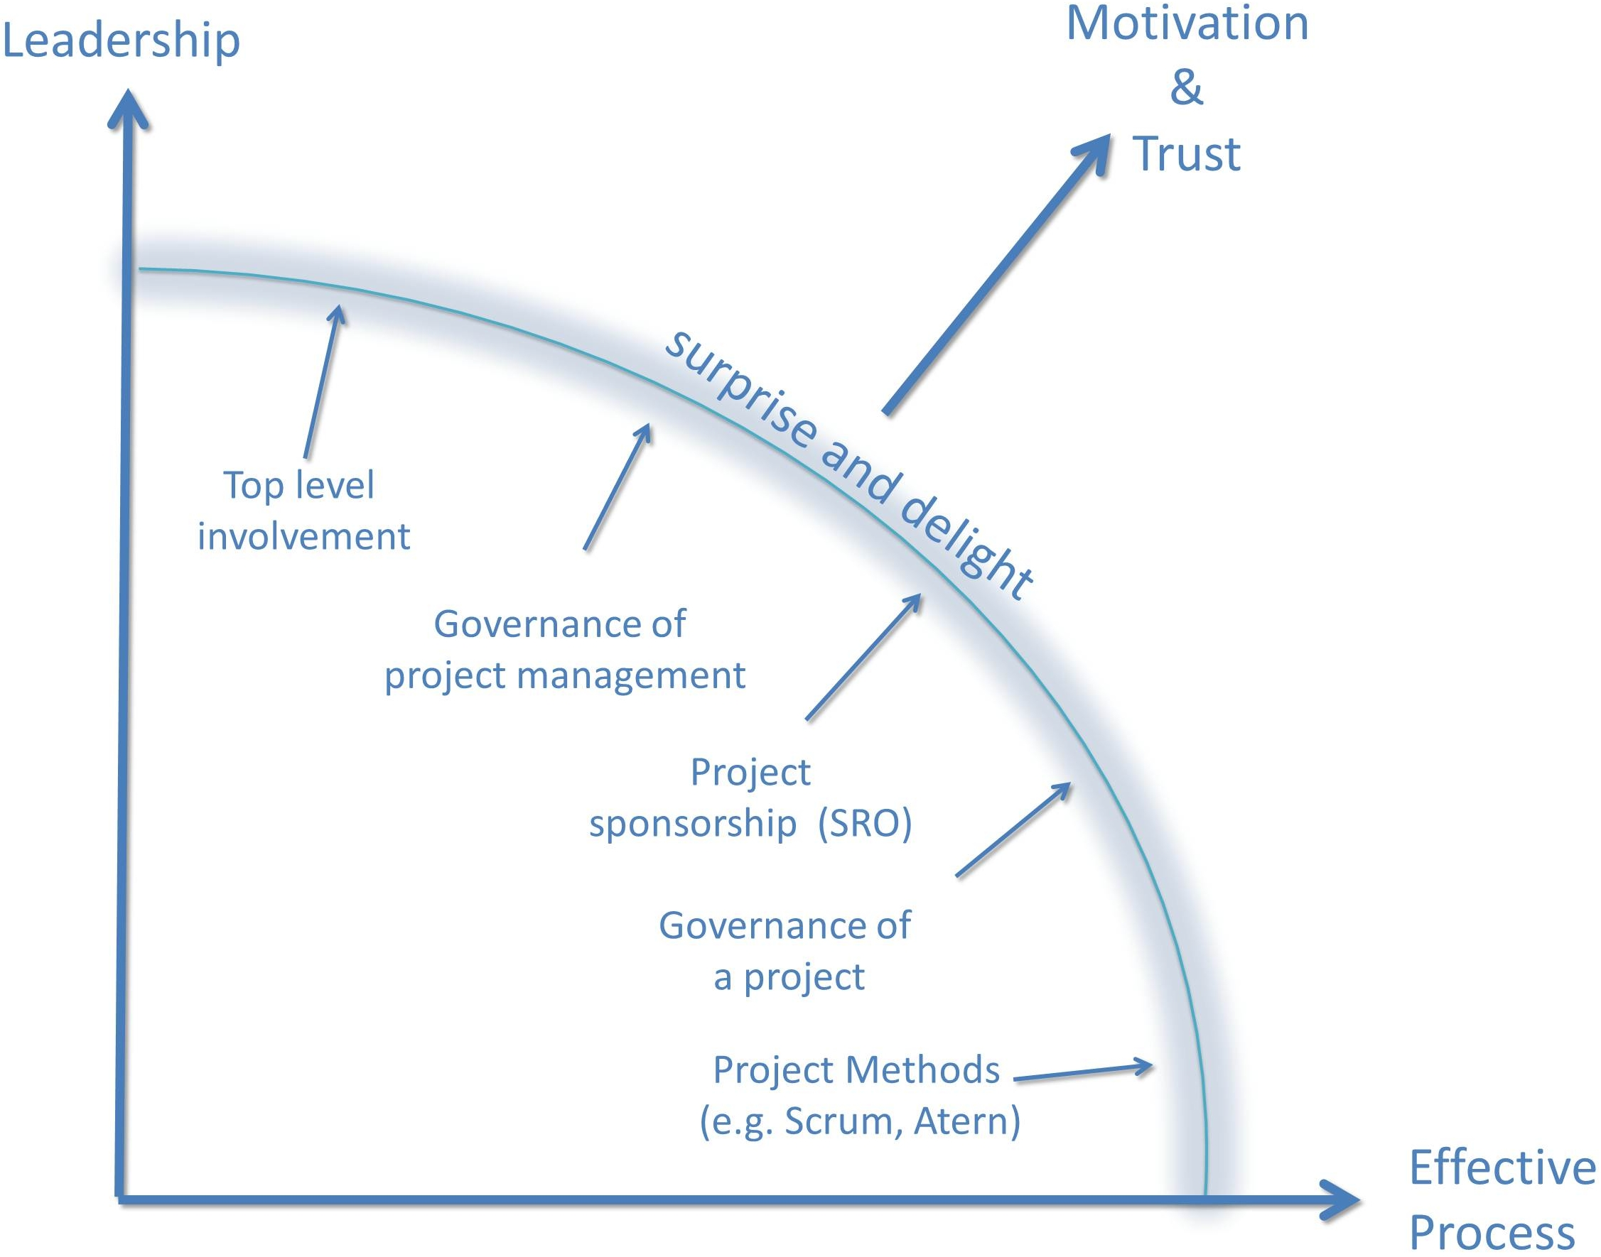

Figure : The five factors contributing to motivation and trust

Risk management tends to be a bottom-up driven process, not a top management led activity. By this I mean that often it becomes a case of ‘management by risk register’, where various bottom-level, known technical risks are identified and tracked individually, without an analysis of how they interact and could cause catastrophic problems.

Let us look at a case of risk management where the interaction between leadership and process was critical: the case of a project document that was leaked to the media, causing a major political row.

In 2012, the UK National Health Service (NHS) was finalizing preparations for a major project to change its organization. Over 90,000 staff would be directly affected. The benefits of the changes were expected to be better health outcomes, fewer avoidable hospital admissions, and a “genuinely patient-centered approach to services”. An annual saving of £20bn was expected, and much objected to by healthcare workers.[2]

The project involved a fundamental change to the funding of the NHS which required primary legislation (the Health and Social Care Bill) to be passed by Parliament. This was bitterly fought against by the opposition party. A member of the public had made a Freedom of Information (FOI) request to be provided with a copy of the related risk register that evaluated the proposed reform plans. However, there were two risk registers in existence. An operational risk register and a transitional risk register. The former was authorized for release, but the latter was not because:

“It was covered by protection for information that relates to the formulation or development of Government policy.” [3]

However, a version of the transitional risk register that was at least a year out of date was leaked to Roy Lilley, a bloggerwho published it on the Internet. It revealed that some risks from the government’s policy had been previously assessed as very high probability and impact, notably:

* Devolution of the organization being a risk to the NHS's ability to cope with emergencies
* Greater costs if greater use was made of the private sector
* The danger that the new system would be set up too quickly
* Potential loss of financial control. [4]

This case illustrates the importance of top management involvement, review, and leadership in the formulation of project direction. The leaked risk register, which was marked “draft”, was over one year old when it was leaked, and was only a list of potential, not actual problems. However, this did not stop it being widely quoted in the media and its contents being used as ammunition by the opposition leader in Parliament at Prime Minister’s question time. The position of the Secretary of Health came under intense attack not just from the opposition but also from within his own party, and required the Prime Minister’s personal support for the reforms to continue.[5]

The difference between strategic operational risks and transition risks has been widely misunderstood. In many cases organizations focus on only operational risks, even when risky major projects are underway. Table 1 on page 147) gives an overview of how three major delivery departments in the US and the UK manage risk, at the strategic operational level and at the transition/project level.

Both these organizations have adopted the COSO Enterprise Risk Management Framework (ERMF). It was developed by the Committee of Sponsoring Organizations of the Treadway Commission (COSO), which provides guidance on organizational governance issues. COSO has wide support from all major accounting bodies in the USA and UK, and the ERMF has been widely adopted as a standard for managing operational risk. However, it does not have any major components regarding managing the risk from change programs.[6] Change management is often a blind spot not just in such standards, but also the corporate risk management processes set up to conform to them. Weaknesses in overall risk management leadership and policy can result in ineffective recognition of risks to the organization that can come from change programs. For example, the US Internal Revenue Service needed to replace its aging legacy computer systems urgently because they cannot easily support online customer service. A $210m program was set up in 2011, comprised of three large component projects.[7] However, risk management guidelines were not followed resulting in inconsistencies in risk management practices and no consolidated view of risks to top management.[8]

The GAO has been worried about both operational and project risk management in the US government for many years. It has developed its own model for organizational risk management, but has found it difficult to encourage structure in these processes. For example, in 2008 it convened a risk management forum for senior staff from DHS and related agencies. The participants could not reach consensus on integration of risk reporting relationships within the organization, and identified risk communication as the single greatest challenge to using risk management principles. A recommendation was that the Government should develop a national strategic planning process for risk management.[9]

On the other hand, UK Government departments base their risk management approach on central guidance that is given in the Treasury Orange Book.[10] This guidance does not specify a specific standard set for risk management in the Government, but establishes principles for a framework for risk management, suggesting several standards, which could be referenced, namely:

* The COSO ERMF[11]
* The UK Institute of Risk Management (IRM) Standards[12]
* The Australian/New Zealand standard (since ratified in 2009 as an international standard ISO 31000)
* The Canadian government Framework for the Management of Risk (updated in 2010). [13]

Both the UK Treasury Orange Bookand the Canadian Risk Management framework explicitly recognize project risk as special. They refer to the need for integration of the monitoring of transition (i.e., project) risks into strategic risk management and give instruction as to where top management can find further guidance:

For Canada:

“The management of projects … integrated across the department appropriately for the level of project risk and complexity … This approach should ensure that accountability for outcomes is clear, appropriate controls are in place to minimize risk … and outputs and outcomes are monitored and reported … Ministers have responsibility for the administration of projects in support of the mandated programs of their departments.” [14]

For the UK:

“Risk management is a structured approach to identifying, assessing, and controlling risks that emerge during the course of the policy, project, or project life cycle. Its task is to ensure an organization makes cost-effective use of a risk process that has a series of well-defined steps to support better decision-making through good understanding of the risks inherent in a proposal and their likely impact.” [15]

The IRM guidance requires identification of project risks separate from strategic risks and requires their incorporation at the “conceptual stage of projects as well as throughout the life of a specific project.”[16]

The Australian/New Zealand risk management standard is now an International Standard.[17] It requires risk management to be an integral part of all organizational processes and “not a stand-alone activity (and should be) part of the responsibilities of management … including all project and change management”.[18]

The UK Department for Work and Pensions (DWP) does not state a strategic policy for integration of change management risk into the monitoring of strategic operational risk with as much clarity as UK Revenue and Customs (see Table 1). DWP’s 2011 annual report did not identify any risks centering about its major IT projects. However, some of these are very large, and have huge uncertainties.[19] For example, the Automated Service Delivery (ASD) project was suspended in February 2012 after being used in pilot sites as a proof-of-concept. The ASD was a new system intended to prove the idea of self-service by citizens over the Internet. The project was based on research that concluded that the new online service could expect over 40% uptake from benefit claimants on Jobseeker’s Allowance.[20] The project had been set up to develop the system using some agile approaches. Initially progress seemed good. An internal confidential Gateway report optimistically stated that:

In terms of the use of Agile within Government, DWP also have the best current experience via their Automated Service Delivery (ASD) Programme.[21]

The team, though, were using a “slightly less lean” version of an agile method based on an “interpretation” advised by consultancy firm Accenture. The system that was delivered was suspended because it was not adequate, and a complete overhaul of the system, which had cost over £15.4m to develop, was announced.[22]

The DWP Universal Credit project is one of the largest IT-enabled projects ever undertaken by the UK government. It aims to change benefits and tax credits for those who are out of work with one universal system. This is in order to ensure that once a claimant gets into work, they will always be better off. At its peak, it had over 750 technical, development, and project staff developing the new systems and operations using a highly tailored version of the Scrum method. It is using a variant of the processes that the ASD project had claimed to be ‘agile’. DWP plan to run the first Universal Credit pilot in spring 2013, when the success or not of the ‘tailored’ version of Scrum that has been adopted can be assessed.[23]

I have focused here on leadership by harnessing the power of risk management processes – this is one very important aspect of how top management should get involved with and keep involved with change projects. Similarly, issue management and decision-making should be led *from the front*, and not managed purely on spreadsheets. One sure way to motivate people is to trust them. The effective and generous delegation of decision-making and the ability to respond to risks and issues to the lowest level possible will achieve much of this.

One such method is a top-down method called ‘Failure Mode Evaluation Analysis’ (FMEA). Essentially this is a practical activity, best carried out initially in a workshop of multi-disciplinary experts. The objective is to identify major possible catastrophic outcomes and then work backwards to see how they might come about.

For example, one potential risk could be that a project might be delayed due to problems in data conversion. The participants in the workshop then brainstorm various sequences of events (or sub-risks) that could, if they occur together, cause the ultimate *failure mode* – in this case that Benefit *‘X’* would not occur and thus undermine the case for the project investment.

Table : Three examples of Corporate and Project Risk Management Frameworks used in US and UK Governments

| **Department** | **Strategic Operational Risk Management Policy** | **Project Risk Management Policy** |
| --- | --- | --- |
| US Internal Revenue Service (IRS) Running Costs: $12bn/annum 107,000 staff | Enterprise Risk Management (ERM) leadership is directed by the Office of Program Evaluation and Risk Analysis (OPERA). Enterprise-wide perspective of risks exists at the agency level.[24]  No specific references at policy level to leadership on internal risks arising from change projects.[25] | A tiered governance approach ensures each IT project is governed at the appropriate level within the organization. Potential project risks are escalated as needed.[26] |
| UK Revenue and Customs (HMRC) Running Costs: £3,7bn/annum 66,000 staff | Implemented a corporate risk management approach in FY 2011. Each business area of the Department has a Lead Risk Champion and Business Risk Partner who support the Executive Committee in managing risk. A Corporate Risk Management function provides central support. [27] | Risk Management Framework includes change management. Risk governance enables a line of sight between the various projects and core business. [28] |
| UK Work and  Pensions (DWP)  Running costs £510m/annum 121,000 staff | The Executive Team provides corporate leadership to manage risks and opportunities. Chief Executives of the Department’s Agencies and Non-Departmental Public Bodies (NDPBs) are accountable for the maintenance and operation of the system of internal control and risk management in their business areas.  Risk Business Partners are in place to support improved risk management in the Department’s Agencies and Policy functions. | A Change Delivery Sub-Committee supports successful delivery of the portfolio of mission-critical projects. No specific project risk management strategy. [29] |

Governance of Agile Project Management

Effective governance of the practice of project management in an organization is a factor that requires leadership by example and just enough process to ensure that the change initiatives are under control.

In 2000, for example, the US Department of Energy strengthened its project management policies and guidance, so as to measure the performance of its projects, and thus improve the quality of federal oversight. The first key area that DOE focused on was strengthening its project management policies and guidance to incorporate industry practices as recommended by the National Research Council. In its 1999 report, the council had urged the DOE to adopt comprehensive project management policies and to emphasize early, detailed planning for projects.[30]

Therefore, the DOE issued a project management order in 1999 followed in 2003, by a comprehensive project management manual, thus instituting the process part of the governance equation.

The leadership dimension was addressed by emphasis on integrating project teams, each major project led by a federal project director. A multidisciplinary approach was encouraged to bring together expertise from project specialists from a central program office, and legal and contracting experts from the Office of General Counsel and other experts in safety, security, and environmental areas.

However, this process led approach had limited impact in some DOE agencies. The National Nuclear Security Administration, for example, had:

“Not developed a project management policy, not implemented a plan for improving its project management efforts, and not fully shared Project Management Lessons Learned Between Its Sites.” [31]

Table 2 presents the 13 components identified by the UK Association for Project Management as necessary for effective Governance of Project Management. I have categorized these into those that have predominantly a *leadership* dimension, and those that have mainly a *process* dimension. As can be seen, although eight of the 13 are fundamentally about *leadership*, the remaining five rely upon *process.*

Moreover, there is a great deal of interaction between these principles. For example, principle 3 focuses on the requirement for clarity of change management roles, which in the real-world are defined by relationships and behaviors more than documented scoping statements and responsibilities. However, principle 3 depends to a great deal on effective recognition of the need for project structures and organization, which is represented by principle 2.

A quick note on terminology: In Canada and the UK, the term *Senior Responsible Owner* (SRO) is commonly used in government to mean what is generally known as the *project sponsor* or *project board chair* elsewhere. In addition, by *board* I mean the body for strategic decision-making for the public entity concerned. In the US, this might be the office of the departmental Secretary and his/her supporting executive board or top management team (the undersecretaries and assistant secretaries for example). The Chief Financial Officer is often an Assistant Secretary level, but with a direct report in at, effectively, decision-making top management level.

Conclusions

In this chapter, I have explored the first two of the five major factors in building motivation and trust:

* Top management involvement

Governance of Project Management

Of all the five factors, top management involvement is the one that depends most on leadership skills. It is important when leading a large, complex project that leadership is channeled through effective processes that are light enough not to weigh down the project teams involved. They must be rigorous enough to meet the needs of open and honest transparency.

Table : Principles of Governance of Project Management [32]

| **No.** | **APM Governance of Project Management Principle** | **Dimension** | **Agile implication** |
| --- | --- | --- | --- |
| 1 | The board has overall governance of project management responsibility. | Leadership | Top management should exhibit behaviors consonant with the Agile manifesto. |
| 2 | The organization differentiates between projects and non-project based activities. | Process | Continuous or incremental change implies a *lean* approach, not a project approach. |
| 3 | Roles and responsibilities for the governance of project management are defined clearly. | Leadership | The top management team has a *tight* and disciplined governance approach, intervenes at appropriate points, and is not over controlling. |
| 4 | Disciplined governance arrangements, supported by appropriate methods, resources, and controls are applied throughout the project life cycle. Every project has a sponsor. | Process | Agile team processes should have clear direction. In DSDM supplied by the Business Sponsor at the top level and the Business Visionary at day-to-day level. Considering extending or dividing the Scrum concept of Product Owner into a strategic Product Sponsor and a more detailed and involved Product Visionary role. |
| 5 | There is a demonstrably coherent and supporting relationship between the overall business strategy and the project portfolio. | Leadership | Top management must work with project sponsors/product owners to emphasize cooperation and coordination between projects and overall strategy. |
| 6 | All projects have an approved plan containing authorization points at which the business case, inclusive of cost, benefits and risk is reviewed. Decisions made at authorization points are recorded and communicated. | Process | Mechanisms are required that keep an overview of all major projects. These mechanisms should comply with the Agile Principles, not require over-documentation, Big Design Up-Front (BDUF) planning and other anti-agile processes. |
| 7 | Members of delegated authorization bodies have sufficient representation, competence, authority, and resources to enable them to make appropriate decisions. | Leadership | Top management should delegate to the greatest extent that is responsible (the concept of *subsidiarity*), this will demonstrate trust and increase motivation. Teams should self-organize. |
| 8 | Project business cases are supported by relevant and realistic information that provides a reliable basis for making authorization decisions. | Process | Business cases should concentrate on analyzing options and emphasizing assumptions and risk, not on justifying one course of action by providing spurious detail. |
| 9 | The board or its delegated agents decide when independent scrutiny of projects or project management systems is required and implement such assurance accordingly. | Leadership | Independent scrutiny, whether in the form of ‘health checks’ or audits should be in the spirit of checking team behaviors and project outputs, not documentation and working papers. (Although proof of adequate testing often must be supported by good documentation. The concept of *agile auditing* is discussed in more detail in a later chapter). |
| 10 | There are clearly defined criteria for reporting project status and for the escalation of risks and issues to the levels required by the organization. | Process | Conventionally, escalation to top management is required when projects go outside theircost, time or quality tolerances. BUT: In agile projects, it is *scope* that is the parameter for flexing – so set Red/Amber/Green tolerances based on whether scope is being delivered. |
| 11 | The organization fosters a culture of improvement and of frank internal disclosure of project management information. | Leadership | At the end of every iteration, top management should expect and encourage a *retrospective* meeting to be held. A record is made of lessons learned, and these are used to improve the team processes. |
| 12 | Project stakeholders are engaged at a level that is commensurate with their importance to the organization and in a manner that fosters trust. | Leadership | The default position should be that as many stakeholders as practically possible are involved in the on-going design and decision-making – even if some are fundamentally opposed to the project. |
| 13 | Projects are closed when they are no longer justified as part of the organization’s portfolio. | Leadership | Do not be afraid to stop a course of action if it is no longer justified. If the assumptions in a business case are no longer valid, then consider a different option for implementation. Project cancellation at the right time is a successful decision – allowing a project to continue into failure is abdication of leadership responsibility. |

Words such as *empowered*, *motivated*, and *supported* appear at the top of the list of what teams want from agile, together with a shared vision of success and elimination of external obstacles.[33] To provide this, effective governance of project management is required across the organization.

In the next chapter, I will explore the other three factors that motivate the team and all others involved or impacted by a project – those three factors lie more along the process dimension, but still require effective leadership to be implemented.

Agile Leadership Behavior Five – Part B: Create Trust (Through Process)

Build projects around motivated individuals. Give them the environment and support they need, and trust them to get the job done.

Agile Manifesto Principle Five

In the last chapter, I explained how agile behaviors engender motivation and trust on agile projects, and introduced the concept that these behaviors work on the two dimensions of *leadership* and *process*. The main argument of this book is that agile leadership is of key significance, much more so than the agile process to be used. In this chapter, I explore the need for “just enough process”, and the dangers of too much.

The Dangers of Being Addicted to Process

Dave Morgan describes how the U.S. Department of Defense used agile to replace an aging system for scheduling satellite tracking stations after three failed attempts and $20m wasted. The development team was “addicted to the process” of waterfall software development based on theoretical written specifications. There were fundamental problems with the project organization – the team rarely talked to the customers, and they were on two-year rotations of duty that reduced continuity and commitment. After the three failed attempts to carry out the upgrade, there were only two major alternatives available. First, to replace the failing project with another multi-year waterfall development, or second, to use prototyping, and adopt an iterative approach. The team decided on the latter approach. Although management had approved the budgets, they were unaware that the team had adopted the agile approach. This was a *covert agile* project.

The project manager satisfied contractual and audit requirements by externally delivering the necessary documentation. However, agile “by stealth” was used for team processes. With a target of only 18 months for project completion, a series of short deadlines were agreed, each delivering working software with the appropriate documentation being delivered by a process of ‘back documenting’ the working solution. The team developed their internal processes as the development went underway. They adapted many ideas from Scrum and XP. After a while the “tense environment based on distrust” had evolved into one based on “collaboration and hope”.[34]

The customers were unaware that a new method was being used, they just saw working software, and faster. They were able to interact with the team more effectively face-to-face than through paper specifications. Dave Morgan cites three important lessons for government projects:

* Choose a process because it is going to deliver – not because a method is the latest fad
* Lead the teams to discover a process rather than force it on them
* Ensure frequent customer interactions.[35]

The Secure Government Gateway

Microsoft found that good process could be a very effective way of enabling trust in delivering the £147m UK Government Gateway. It developed the system by giving *slack and empowerment* to the team. The approach to project management combined the essence of agile with the advantages that effective process can bring. Evidence, both anecdotal and from research, shows that attempts to implement a ‘perfect’ process result, paradoxically, in wasted time and effort. The organization does not react fast enough to the need to modify processes once they are documented and agreed. The result can be a straitjacket for everyone.[36]

The Government Gateway project manager was careful to consider what constitutes an “important”process. These were not selected based on size, value, or criticality, but based on whether documentation of the process added value by reducing the risks of *management error*:

* *Tampering* when everything is normal. If a process is demonstrably under control, it should be left alone.

*Failing to intervene when a process is out of control*. In such cases, aggressive issue and risk management are required. [37]

By marrying leadership skills, a clear objective, and agile processes, they developed this high transaction volume application, which has now been adopted by over 70 public sector bodies, running more than 200 secure services. Availability in 2011 was 99.9% for the 2.5m secure information update transactions processed each month.

Only Define Essential Processes

So, rather than aiming for all processes to be comprehensively defined, you should consider which processes are running well, and which are not – and then concentrate on those that are critical. Many attempts to define processes start with the easiest to define – those that are running smoothly already and are easy to document. The documentation then just freezes an effective process in place doing no good, but inhibiting the team’s capacity to adapt!

Microsoft also adapted Deming’s Principles for Transformation[38] to identify five Agile Leadership Behaviors that can help create trust:[39]

* Cease dependence on quality control to achieve quality, instead focus on quality assurance throughout the life cycle
* Training on the job
* Drive out fear
* Break down barriers between departments
* Remove barriers to pride of workmanship, focus management on quality rather than production numbers.

The *leadership* dimension plays a major role not only in creating trust directly, but also in encouraging the implementation of just the right degree of emphasis on the *process* dimension to motivate the team and engender trust from top management and with customers. As we will see in this chapter, these issues can be effectively addressed by the application of leadership through three main factors influencing motivation and trust introduced in the last chapter (see Figure 1) that I will now explore in some more detail.

Effective Project sponsorship

Different methods define alternative roles for who or what a project sponsor is. For example, Scrum defines the role of *product owner* as the decider in critical development decisions. The project sponsor role in government projects may often be called *Project Director* or *Senior Responsible Owner.* In DSDM projects (as we saw in the CIDS case study in Part I), the term Business Sponsor is used. Whatever the terminology, the important thing is that someone leads the project and creates a buffer between the often potentially chaotic outside world and the team members, who have to concentrate on the detail of getting a solution right and to plan and execute its successful implementation.

Research from Norway by Knut Samset shows that large complex government projects are prone to risk-negligence and lack of accountability due to lack of effective project sponsorship. These projects are often characterized by complex political drivers and dispersed lines of responsibility. If the project leadership is driven by short-term personal ambitions, then the project may not deliver public benefit, and may fail.

The cure that he suggests is that:

* Risk and accountability should be much more centrally placed in decision-making
* Leadership in risk analysis and risk management should be present
* The role of government should be at arm’s-length distance from the project
* Accountability in decisions should be transparent and measurable. [40]

To achieve this, each project sponsor must:

* Take responsibility for all decisions, and yet still delegate to the lowest appropriate level – the concept of *subsidiarity*

Be the key communicator between the project and the outside world for major issues.

The project sponsor on an agile project should lead on major decisions. Minor decisions are best handled by those on the ‘coal face’ nearest to the users and technology should decide on detail.

In some situations where project start-up has been far from perfect, there may be a plethora of interlocking project boards and investment committees involved. It may take time to unpick these and straighten out reporting lines into a more optimal structure. In the meantime, the project sponsor must relish accountability, not defer to ‘approval by committee’, and not allow the dispersal of responsibility that could ultimately undermine their authority.

The project sponsor must also communicate with superiors, his peers, and with the project team (see Figure 2). Communications can be seen as the external face of risk and issue management. Problems can arise from above (the strategy/policy level), from below (the technical level), and horizontally (from other projects and operations). Therefore, an effective sponsor should be attentive to all three levels.

Responsibility for Decisions

On an agile project, it is important that the project sponsor makes decisions at the latest responsible moment. An early decision before all the key facts are apparent can close down more optimal technical options that should have been considered. Early closure of differing options is often a tempting tactic. The sponsor is often faced with external expectations (especially from arms of the government responsible for financial approval) to justify the project through a detailed Business Case. Committing to one option in detail at that stage merely creates a superficial appearance of scientific objectivity and precision, when little evidence is available to support the various surrounding assumptions.

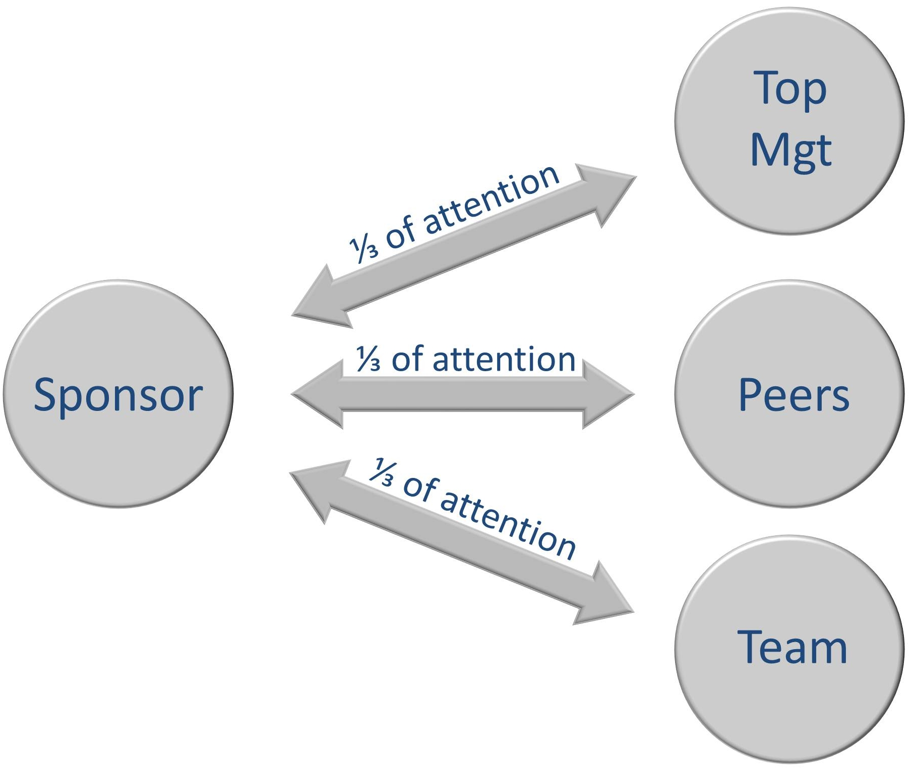

Figure : The Project Sponsor Should Be Attentive to Communication at All Levels

Running Parallel and Optional Processes

One major aspect of the role of sponsorship, whether it is carried out by an individual or by an organization, is to organize project processes to run in parallel whenever possible. If one cannot start before another, it creates a *critical* path that elongates the entire project. Delay in the preceding task affects the succeeding one.

A GAO report on the Federal Transit Administration (FTA) and its equivalents in Canada and the UK raised a concern regarding major capital project processes. These were not completed concurrently, and transfer of risk to private sector partners was ineffective.[41] The FTA did not take advantage of the possibility of running processes in parallel, or incrementally. Over the previous decade, the New Starts program had provided over $10 billion for mass transit projects. The problem was that a conventional “design-bid-build” approach was taken. Separate entities were contracted for each sub-project, but much of the integration risk remained within the public sector. This approach was “time consuming, costly, and complex”. An alternative incremental approach did exist but little use was made of it. This approach took advantage of *Letters of No Prejudice* and *Early Systems Work Agreements* which would provide the flexibility to cancel a project if it was found not to be feasible after initial work had started. *Letters of Intent* could also be used to allow the FTA to signal “an intention to obligate federal funds at a later date if and when funds become available”.[42]

The project sponsors had made little use of this flexible contracting approach. The FTA had only ever issued three Letters of Intent and four Early Systems Work Agreements. Several pilot projects had failed because of a lack of interest from bidders. The problem, the GAO concluded, was that these flexible contracting approaches could not be used with waterfall projects. The root cause, they pointed out, was a lack of coordination and encouragement for flexible project management from senior leaders.” [43]

Best Practice Process Guidance Can Enable Agile Adoption

Having sets of guidance materials and standard contracts that stress flexibility and incrementalism can greatly assist the project sponsor and the organization to achieve agility in its widest sense. The provision of project management advice and assistance for mass transit project sponsorship, for example, is provided centrally in Canada and the UK.[44] In an international review, the GAO concluded that these sources of best practice advice helped “foster good public-private partnerships and helped further protect the public interest by ensuring consistency in contracts and serving as a repository of institutional knowledge.”[45]

The Sponsor Acting As an Interface

Although the project sponsor is the arbiter for issue resolution and risk management, it is important that this role does not become a bottleneck. A balance is required between firmness and autocracy. An autocratic approach can create two main problems. First, if the sponsor insists on being the main route for communications, this can reduce the potential effectiveness of close co-working between the team and the business and stakeholders. Second, if decision-making is not devolved as far as is safe and practical, it can mean that even minor decisions will need to be referred upwards to the sponsor, thus slowing the pace of development.

An interesting example came to my attention where devolved decision-making became crucial in a developing country. In Bhopal, India, an agricultural advice system was being developed to provide information to the managers of over 500 farms. The project used the Scrum method, and at an early stage, it became obvious that having a government official as a *product owner*, based in the research center, when the researcher was based in the farming community would be problematic. Therefore, a local farmer was appointed as *product owner*.[46] If minor decisions can be left to the discretion of those closest to the detail, then decisions can be made as to which features will be ready or not for each release of the technical solution. These decisions can be left until later, and therefore more flexibility can be retained as to the exact nature of delivery until it is necessary to decide.

Efficient Governance of an Agile Project

In the last chapter, I discussed the importance of the governance of projects across an organization. In some organizations, the *governance of project management* might be widely standardized (for the better or for the worse). Some organizations may just focus on controlling strategic change initiatives.

However, every project must make arrangements (whether formal, informal, consistent, inconsistent, ad-hoc or standardized) for reporting to top management and for making decisions on its various strands of work.

The organization as a whole will make a decision on how each individual project will be governed by top management, and there are two main approaches, which can be used either apart or together:

* Project Portfolio Management, and

Program Management.

First, *project portfolio management* should allow projects to run themselves with just the right amount of central oversight. Each project sits within the *portfolio* of change initiatives, some big, some small, some urgent, some on hold. Each project must give evidence that it is still relevant to the organization’s strategy and that it is making good progress. This portfolio management may be an ad-hoc arrangement that is not tightly defined, or it may have highly standardized reporting requirements.

Second, *program management* can be used to package together related projects that have common purposes and/or share a common development resource. A *program manager* manages these related projects, coordinating dependencies, resources, and priorities to maximize an overall program business case. This approach can turn into an expensive overhead, however, and UK Cabinet Office guidance advises that it should not be used as a matter of course unless it adds value over and above its additional costs.Many organizations manage a portfolio that is a mix of individual projects and some large programs.[47]

The agile approach taken must recognize top management requirements for governance across the portfolio of projects, and must also address the governance of the internals of each project. Here, the involvement of the project sponsor is critical. This role will enable the agile project to succeed, or inhibit its flexibility. The sponsor needs to find the right balance between formal channels of communication and control, and the delegation of decision-making and flattening of layers of hierarchy.

Good project governance is a factor that, when done well, can really motivate a team. It should meld together sponsor level leadership with realistic processes for steering the team’s direction, reporting progress, and making decisions.

Agile Methods can Motivate and Empower the Team

One of the attractive aspects of agile for team members is that they decide on matters that they are best placed to control. These are typically:

* Deciding on the optimum technical solution
* Prioritizing delivery in chunks to gain the greatest benefit in the shortest time
* Exploration of the interactions between requirements and possible solutions – the ‘art of the possible’
* Quickly responding and adapting to new external factors, whether these are changes in policy/business environment, or new technical solutions that become available during the project

Lack of trust between top management and the team often leads to an unhealthy increase in formal process. Agilists use the term *ceremony* as a catchall label for such processes. The agile approach aims to inspire trust between the parties, reducing ceremony to a minimum. If rules are overused, then cooperation will be delayed as negotiation takes place to agree the rules. People will waste time arguing over and trying to enforce rules entailing what economists call *transaction costs* as an unnecessary overhead to the project.[48]

Adopting Agile Processes at StratCom

DOD Strategic Command (StratCom) is responsible for military space operations, information warfare, and command of the United States nuclear arsenal. [49] Anne Fruhling investigated its adoption of some eXtreme Programming (XP) techniques. She found that while many of the practices of XP techniques are intuitive and straightforward to adopt, some were culturally challenging and met with resistance. Training and expert support would have helped together with clearer leadership of the move to using XP techniques.

There was initial resistance to the some key concepts within XP techniques. For example, test driven developmentrequires programmers to write code and test it at very frequent intervals. Kent Beck, its creator, explains:

“Programming and testing together is faster than just programming … the gain in productivity comes from a reduction in the time spent debugging – you no longer spend an hour looking for a bug, you find it in minutes.” [50]

*Pair Programming* was another XP practice that was new to the team at StratCom. This is a technique where developers write the code for a program together (and of course continually test it together as part of the test driven development approach). The idea is that a continual dialogue takes place and the two developers come to a common understanding of the problem. By changing the pairing up of programmers every few hours, ideas spread fast, developers gain a rapid understanding of the solution as a whole, and standards are enforced by the team itself.[51]

At StratCom, these two key concepts of XP met initial resistance. One team did not use them at all. Part of the problem was that pairing up people to program together who are of different abilities can be problematical. For example, if a novice is paired up with an expert, then the programming session will probably degenerate into a tutorial session, and the valuable time of the expert who may have been employed to tackle the most hairy coding challenges may be wasted. When introverts are paired with extroverts, their opinions and expertise are often sidelined.[52] Furthermore, as agile teams should be self-organizing, there will be a tendency for introverts to avoid the practice altogether.

The StratCom teams involved in the research had adopted many agile processes. The teams included stakeholders, not just programmers, they used small increments of delivery, and had a sustainable workload. Researchers identified several lessons:

* Teams should be trained in XP before starting to use it
* No part-time team members – this can be a problem at project startup when many people are not released fully from previous roles
* Good communication between team members can be improved by having regular morning standup meetings

More consideration should have been given at an early stage for the involvement of experts to supply specialist knowledge and skills. For example, at StratCom, although the users were fully involved in making sure that the functions fulfilled the business need, they did not initially have the necessary expertise to explain how the system should be laid out to be easy to use. The development of the search facilities also needed technical database expertise, and the team wasted much time finding out how to achieve certain requirements, when an expert would have solved their problems quickly. [53]

Even though the agile approach had been successful, many stakeholders still felt that detailed pre-planning and documentation would have been better.

This happened despite the fact that perceptions of the quality of the resulting product were high, and that the frequent delivery of new features every two to three weeks rather than every two months was much appreciated.

Anne Fruhling says:

“While this seems directly at odds with the principles and practices of XP, it might also be interpreted as the lack of recognition of the differences between XP and the plan-driven development approach. Thus, this suggests there needs to be more in-depth agile/XP training prior to execution … and additional mentoring and team lead oversight.” [54]

Stephens and Rosenberg’s book “Extreme Programming Refactored” is a very readable introduction to XP. Although broadly supportive of XP, the authors poke fun at some of the more extreme statements made by some advocates of XP. They evaluate the practicality of XP practices in an entertaining manner, while making some serious points. They warn against adopting an XP *extremo culture* – seeking out and following more and more radical development processes without evidential basis. They make the argument that some aspects of XP may not work for some people, and they propose a modified version of XP, which is “less extreme” and may be more suitable for a government environment. The conclusion is that implementing XP in an organization is usually a big-bang process, which is ironic since XP is a very incremental method once it is being used:

“A problem faced by teams wanting to introduce XP into their organization is that XP requires a mind shift in the entire outfit.” [55]

This, of course, is true for the agile approach as a whole, not just the XP techniques. The customization of agile techniques by StratCom was not unusual. Many organizations, in government and in the private sector feel that they need to do so. In effect, *à la carte adoption* of agile methods like XP is the norm. Organizations pick out those ideas that are most closely matched to their existing processes. Techniques and processes are not adopted where the method is too challenging for the culture, or where appropriate training has not taken place. In the case of StratCom, two factors were identified as critical. First, a culture that is ready to change, and second, a technical infrastructure that supports efficient development.[56]

Conclusions

In this chapter, I have explored the last three of the five major factors in building trust (see Figure 1 on page 141):

* Effective Project Sponsorship
* Efficient Governance
* Motivating and empowering the team through agile methods.

We have found that the role of *project sponsor* in an agile project is focused on acting as a buffer to protect the team from unnecessary distractions. The sponsor must also make sure that changes in circumstances are quickly incorporated into the work plan, not just for the development team, but also at program and portfolio levels. To achieve this, governance processes need to be both tight and light. Tight enough to ensure that good decisions and made, and light enough to allow the team to execute them quickly and accurately. This concept, and a further discussion on the challenge (and promise) of XP techniques are both examined further in Part III.

The project team can adapt ideas in agile methods to suit the culture of their organization. Agile teams are self-organizing, and if changes to standard methods are required, they should be empowered to make those changes. ‘Just enough process’ is an effective way of creating trust between the team and those outside who need to have confidence that the project is on the right path.

1. {Vijayasarathy 2008 #250}
2. {NAO 2011 #221}
3. {ADoole 2012 #223}
4. {Lilley 2010 #220}
5. {Conservative Home 2012 #224}
6. {Enterprise risk management 2004 #226}
7. {East 2012 #234}
8. {TIGTA #233: 8} found these problems which a concurrent report prepared by GAO appears to have missed – see {U.S. Government Accountability Office 2011 #235: 4 }
9. {U.S. Government Accountability Office 25/06/2008 #409: 1}
10. {HM Treasury 2004 #227}
11. {Enterprise risk management 2004 #226}
12. {IRM 2002 #230}
13. {Canada 2010 #228}
14. {Canada 2009 #229}
15. {Great Britain. Treasury 2003 #182: 29}
16. {IRM 2002 #230: 6}
17. {ISO 31000 Risk management 2009 #231}
18. {ISO 31000 Risk management 2009 #231: 7}
19. {DWP Department for Work and Pensions 15/07/2011 #232: 69}
20. {Williams 2011 #387}
21. {Agile for Universal Credit 2011 #388}
22. {laffan 2012 #386} and {UK DWP 2011 #389: 85}
23. {DWP Department for Work and Pensions 15/07/2011 #232}
24. {North Carolina State College of Management 2007 #237}
25. {DKBald00 21/06/2007 #238}
26. {IT Modernization Vision & Strategy 2007 #236: 39}
27. {UK HMRC 2011 #225: 40}
28. {UK HMRC 2011 #225: 40}
29. {DWP Department for Work and Pensions 15/07/2011 #232: 101}
30. {U.S. Government Accountability Office 2007 #217: 8}
31. {U.S. Government Accountability Office Jan 2007 #218}
32. Adapted from {UK Association for Project Management 2011 #23}.
33. {Williams 2012 #239}
34. {Morgan 2009 #255: 79–81}
35. {Morgan 2009 #255: 82-82}
36. {Giotis 2003 #251}
37. {Anderson 2005 #243: 193}
38. {Deming 1986 #244: 18–96}
39. {Anderson 2005 #243: 194}
40. {Samset 2006 #252: 4}
41. {GAO 2009 #256: 1}
42. {GAO 2009 #256: 9}
43. {GAO 2009 #256: 38}
44. By the confusingly named “Partnerships British Columbia” in Canada, and by “Partnerships UK” in Britain.
45. {GAO 2009 #256: 38}
46. {Dearden 2010 #257}
47. {OGC 2011 #205: 63}
48. {Hasnain 2008 #258}
49. {Fruhling 2008 #304: 6}
50. {Beck 1999 #62: 46} and also see {Stephens 2003 #100: 8} who, unusually, gives credit to XP for refocusing developers on the importance of frequent unit testing.
51. {Beck 1999 #62: 100–102}
52. {Williams 2003 #381}
53. {Fruhling 2008 #305: 7-9}
54. {Fruhling 2008 #305: 9}
55. {Stephens 2003 #100: 8}
56. {Fruhling 2008 #304: 34}