## AGLPM1 – Unit 2 - ACTIVITY 2: OBSERVE

***1st Agile Leadership Skills:   
Satisfy the Customer***

This document is an excerpt from the book:

“Agile Project Management for Government “

Authored by Brian Werham

Published by Maitland & Strong

Reproduced with permission under license





PMCAMPUS.com / Mokanova Inc

.

© 2003-2016 Mokanova Inc and its licensors. All rights reserved for all countries. PMCAMPUS.com is a trademark and service of Mokanova Inc.

PMI, PMBOK, PMP are owned and registered marks of the Project Management Institute, Inc.

Single use only. Do not download, print, duplicate, and share.

.

*Agile Leadership Behavior One: Satisfy the Customer*

Our highest priority is to satisfy the customer through early and continuous delivery of valuable software.

Agile Manifesto Principle One

You need to satisfy the people that are funding your projects. You need to take notice of those people who may be impacted by the solutions, whether they support them, or object to them. The obvious aim is to make sure that the people who will use the technical solution, commonly called the *users*, are happy. But that is missing the point. There is a broader spectrum of people that have an interest in the system, and we must make sure that where they have influence over the people funding our work we address their concerns. Often it is not obvious who the ‘customer’ is at all, and some thought is required as to whom you really are aiming to please. For example:

* Users: who usually want lots of functions out of a fast, reliable technical solution
* Bosses: who not only set ambitious goals, but want ‘no surprises’ along the way
* Subordinates: who want technical advancement, neat designs, and who may not directly see the benefit of controls and transparency
* Maintainers: who will inherit the technical solution and who want it bug-free and well-documented
* Sponsor/Product Owner: those in a different division or organization who commissioned the system[1]

All other stakeholders perceiving an impact from the implementation of the new solution, its use, or its final decommissioning.

The old adage is that you can’t please all of the people all the time, so your efforts have to be focused on those stakeholders that will be most impacted by the system and also have the most influence over a project – either through direct governance as the boss, or by political or other influence. Some stakeholders may be implacably opposed to the technical solution – for example those who will lose out when it is implemented. The best you can do in these cases is to attempt to reduce the effectiveness of their opposition to the plans.

A successful agile project is one where the customer is the center of focus for the team – both in terms of the product being developed (the *output*) and how it is going to improve the business (the *outcome*).

Waterfall projects are often characterized as big-bangprojects. The customer is forced to wait for years to see results. Both the US and the UK Governments have declared an intention to involve stakeholders more closely as projects progress, but much of the guidance materials still implicitly discourage this.

National audit bodies on both sides of the Atlantic are inconsistent on this issue. If a project is big-bang, it may be criticized for not testing concepts adequately with customers and not being piloted correctly. If incremental, a project may be criticized for moving too quickly and having moved to development before all requirements are agreed with the customers.

In this chapter I describe a method that has had widespread influence in US defense project thinking: Barry Boehm’s *Spiral* approach. Its influence was so great that it was mandated for military developments in Section 804 in public law.[2] However, many projects that claimed to be using Spiral have merely been using it as a cloak to cover a traditional big-bang approach. Later in this chapter I relate the six essential tests you can use to ensure that this does not happen on your agile project.

I also compare the speed and effectiveness of the move to agile project management in the US and UK. We will see that effective direct intervention from a strong Government Chief Information Officer (CIO) in the US has had a profound impact, and that the UK has made progress but has some way to go.

Agile Places the Customer As Top Priority

A comprehensive international survey showed that the first principle of agile has overwhelming support from leading agile practitioners as the most pervasive attribute of success for agile projects. Agile Leadership Behavior One corresponds to Agile Manifesto Principle One, and supports its implementation.[3]

Although the wording of principle 1 assumes that the deliverable from the project is “software”, it emphasizes that the ultimate output are positive business *outcomes*, rather than technical *outputs*. Proponents of agile are keen to emphasize that all the principles can apply to non-software developments. For example, in 2007, the phrase ‘software development’ was used throughout the official Scrum documentation – but had disappeared by 2011, having been replaced by more generic references to ‘product development’.[4] Another example of the more generic use of agile beyond systems development are the Case Studies being used in agile qualifications which emphasize the more general applicability of agile outside of corporate IT work. For example, the 2012 sample paper for the APMG Agile Project Management qualification is based on a SME business which needs to prepare marketing materials for a trade fair.

The Evolutionary Approach to Defense Projects

The GAO has for many years been extremely critical of the F/A‑22 ‘Raptor’ strike aircraft project. The project ran for 20 years.

What began as an effort to buy 650 fighters capable of evading former Soviet radar defenses to escort bombers to targets came to an end in December 2011 with only 195 having been built.[5] From the start, the GAO warned that:

“(The DOD was) not guided by the principles of evolutionary, knowledge-based acquisition … and, as a result, (many projects have) experienced cost increases, schedule delays, and poor product quality and reliability.” [6]

Instead, the GAO recommended an evolutionary approach (such as proposed by Tom Gilb) within a Spiral method (such as that proposed by Barry Boehm) should be used. Development cycles should be kept short, and early use should be made of technologies to prove development concepts (see Figure 6).

It is not just technology development projects that can benefit from evolutionary approaches. The NAO advises that:

“Many … organizations now regard property transformation as (an) evolutionary process. Evolutionary processes suit organizations that are budget constrained, are subject to regular operational changes, and want to create a sense of staff involvement, learning and ownership.”[7]

Government guidance on both sides of the Atlantic has been inconsistent and confusing in this area. In 2001, the dangers of big-bang implementation were recognized by the UK Treasury:

“Unless approved by a central scrutiny group (including the Chief Secretary to the Treasury), no big-bang implementations and developments – we mandate modular, incremental implementations and developments for IT-enabled projects.” [8]

In 2004 another letter was sent extending this guidance “to cover all major acquisition-based projects”. [9] However, this guidance was then superseded in 2007 by a new strategic manual to the heads of departments, where the advice was to merely consider “pilot testing before full roll-out”.[10]

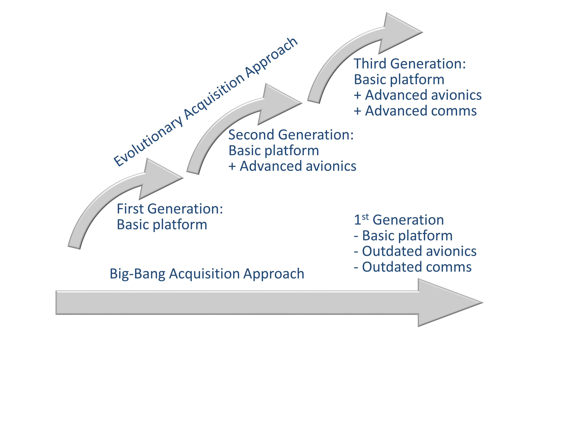

Figure 6: Comparison of Evolutionary and Big-Bang Approaches (Adapted from GAO 2003) [11]

Requirements for modular and incremental development were dropped, and a presumption of the big-bang approach thus implied by an implementation phase only at the end of the project. Furthermore, in 2011 the new UK Integrated Assurance and Approvals guidance described a project model of waterfall 'design, build, test' to be followed finally by implementation, and similarly neglected the advice for incremental development with phased implementation cycles.[12]

The previously acknowledged risks associated with big-bang implementation were also dropped from the list of ‘common failings’ in government projects in strategic guidance for ‘starting gate’ reviews.[13]

In 2006, the NAO issued a report emphasizing that late, big-bang deliveries were dangerous, and gave examples of successful government case studies that had “avoided the strain on organizational resources and the technical and reputation risks of big-bang roll-outs.” [14]

The GAO has recently been promoting agile concepts. In one report on weapon systems it urged the DOD to use more realistic timeframes, and to aim to achieve the best with what is available, rather than over-specify detail in its projects. Instead of projects that last decades and produce very little, delivery of new defense capabilities should be expected within 6 years or less. Programs are more risky as the delivery timescale extends out. In some cases projects had been planned that were over 15 years long, with costs that grew at exponential rates from the original baseline. The GAO advised that:

“The DOD should assimilate new technologies into weapon systems more frequently, accelerate delivery of new technology, hold program managers accountable, and make more frequent and predictable work in production, where contractors and the industrial base can profit by being efficient. Too many major acquisitions currently take the opposite approach by seeking to deliver a revolutionary big-bang capability in one step.” [15]

The GAO has criticized many government and public agency bodies for lack of early demonstration and “knowledge enabled feedback” at early project stages. It criticized NASA's failure to demonstrate technology maturity with realistic models or prototypes before projects were committed to full production.[16]

The US Takes Drastic Action

In the US, Vivek Kundra initiated a comprehensive review of existing technology projects with each department and agency. These Technical Status (TechStat) meetings were long, detailed, face-to-face reviews of all *yellow* and *red* status projects. These reviews were intended to delve deep into each problematical, large-scale IT project with a relentless pursuit of oversight and either revise the plans or halt or terminate it.

The meetings were jointly held with OMB officials and with CIOs from other departments invited to attend as peer reviewers. To kick off the initiative Kundra attended more than three of these meetings a week, publically issuing memos to agencies where problems were found. At the Environmental Protection Agency (EPA), for example, one IT project was found to be one year late and $30m over budget, so Kundra gave the EPA 30 days to put a recovery strategy in place for the project.[17] In August 2010, for example, he held individual sessions with 13 agency CIOs and identified a list of high-risk projects, for each of which each agency had to submit a proposed improvement plan within 30 days.[18]

The Spiral Development Approach

Since 2003, the US DOD has required acquisitions for advanced technology:

“To be deployed in the shortest time practicable. Approved, time phased capability needs matched with available technology and resources enable evolutionary acquisition strategies. Evolutionary acquisition strategies are the preferred approach to satisfying operational needs.” [19]

This directive stated that the Spiral development process, originally proposed by Barry Boehm, would be the preferred process for executing such strategies. Boehm’s Spiral approach stresses the incremental development of the definition of the requirement. A cycle of increasing definition and commitment to a design approach is proposed, where each iteration starts with a risk assessment. The spiral starts off with some outline work on the development objectives, and then risks to those objectives are identified and analyzed “candidly and completely”. The highest risks to success are then addressed by the creation of working prototypes in increasing sophistication and operational readiness (see Figure 7).

Each iteration concludes with feedback from experiences in building the solution, replanning, and revisiting the initial objectives (which I have paraphrased in Figure 7 as the ‘Business Case’).

Since the specific adoption of the Spiral Model in DOD Instruction DOD‑5000, Barry Boehm defined six *Spiral Essentials* to guard against “false spiral activity” which can lead to customer dissatisfaction. Some agilists brand these projects as *fragile* rather than agile*.*

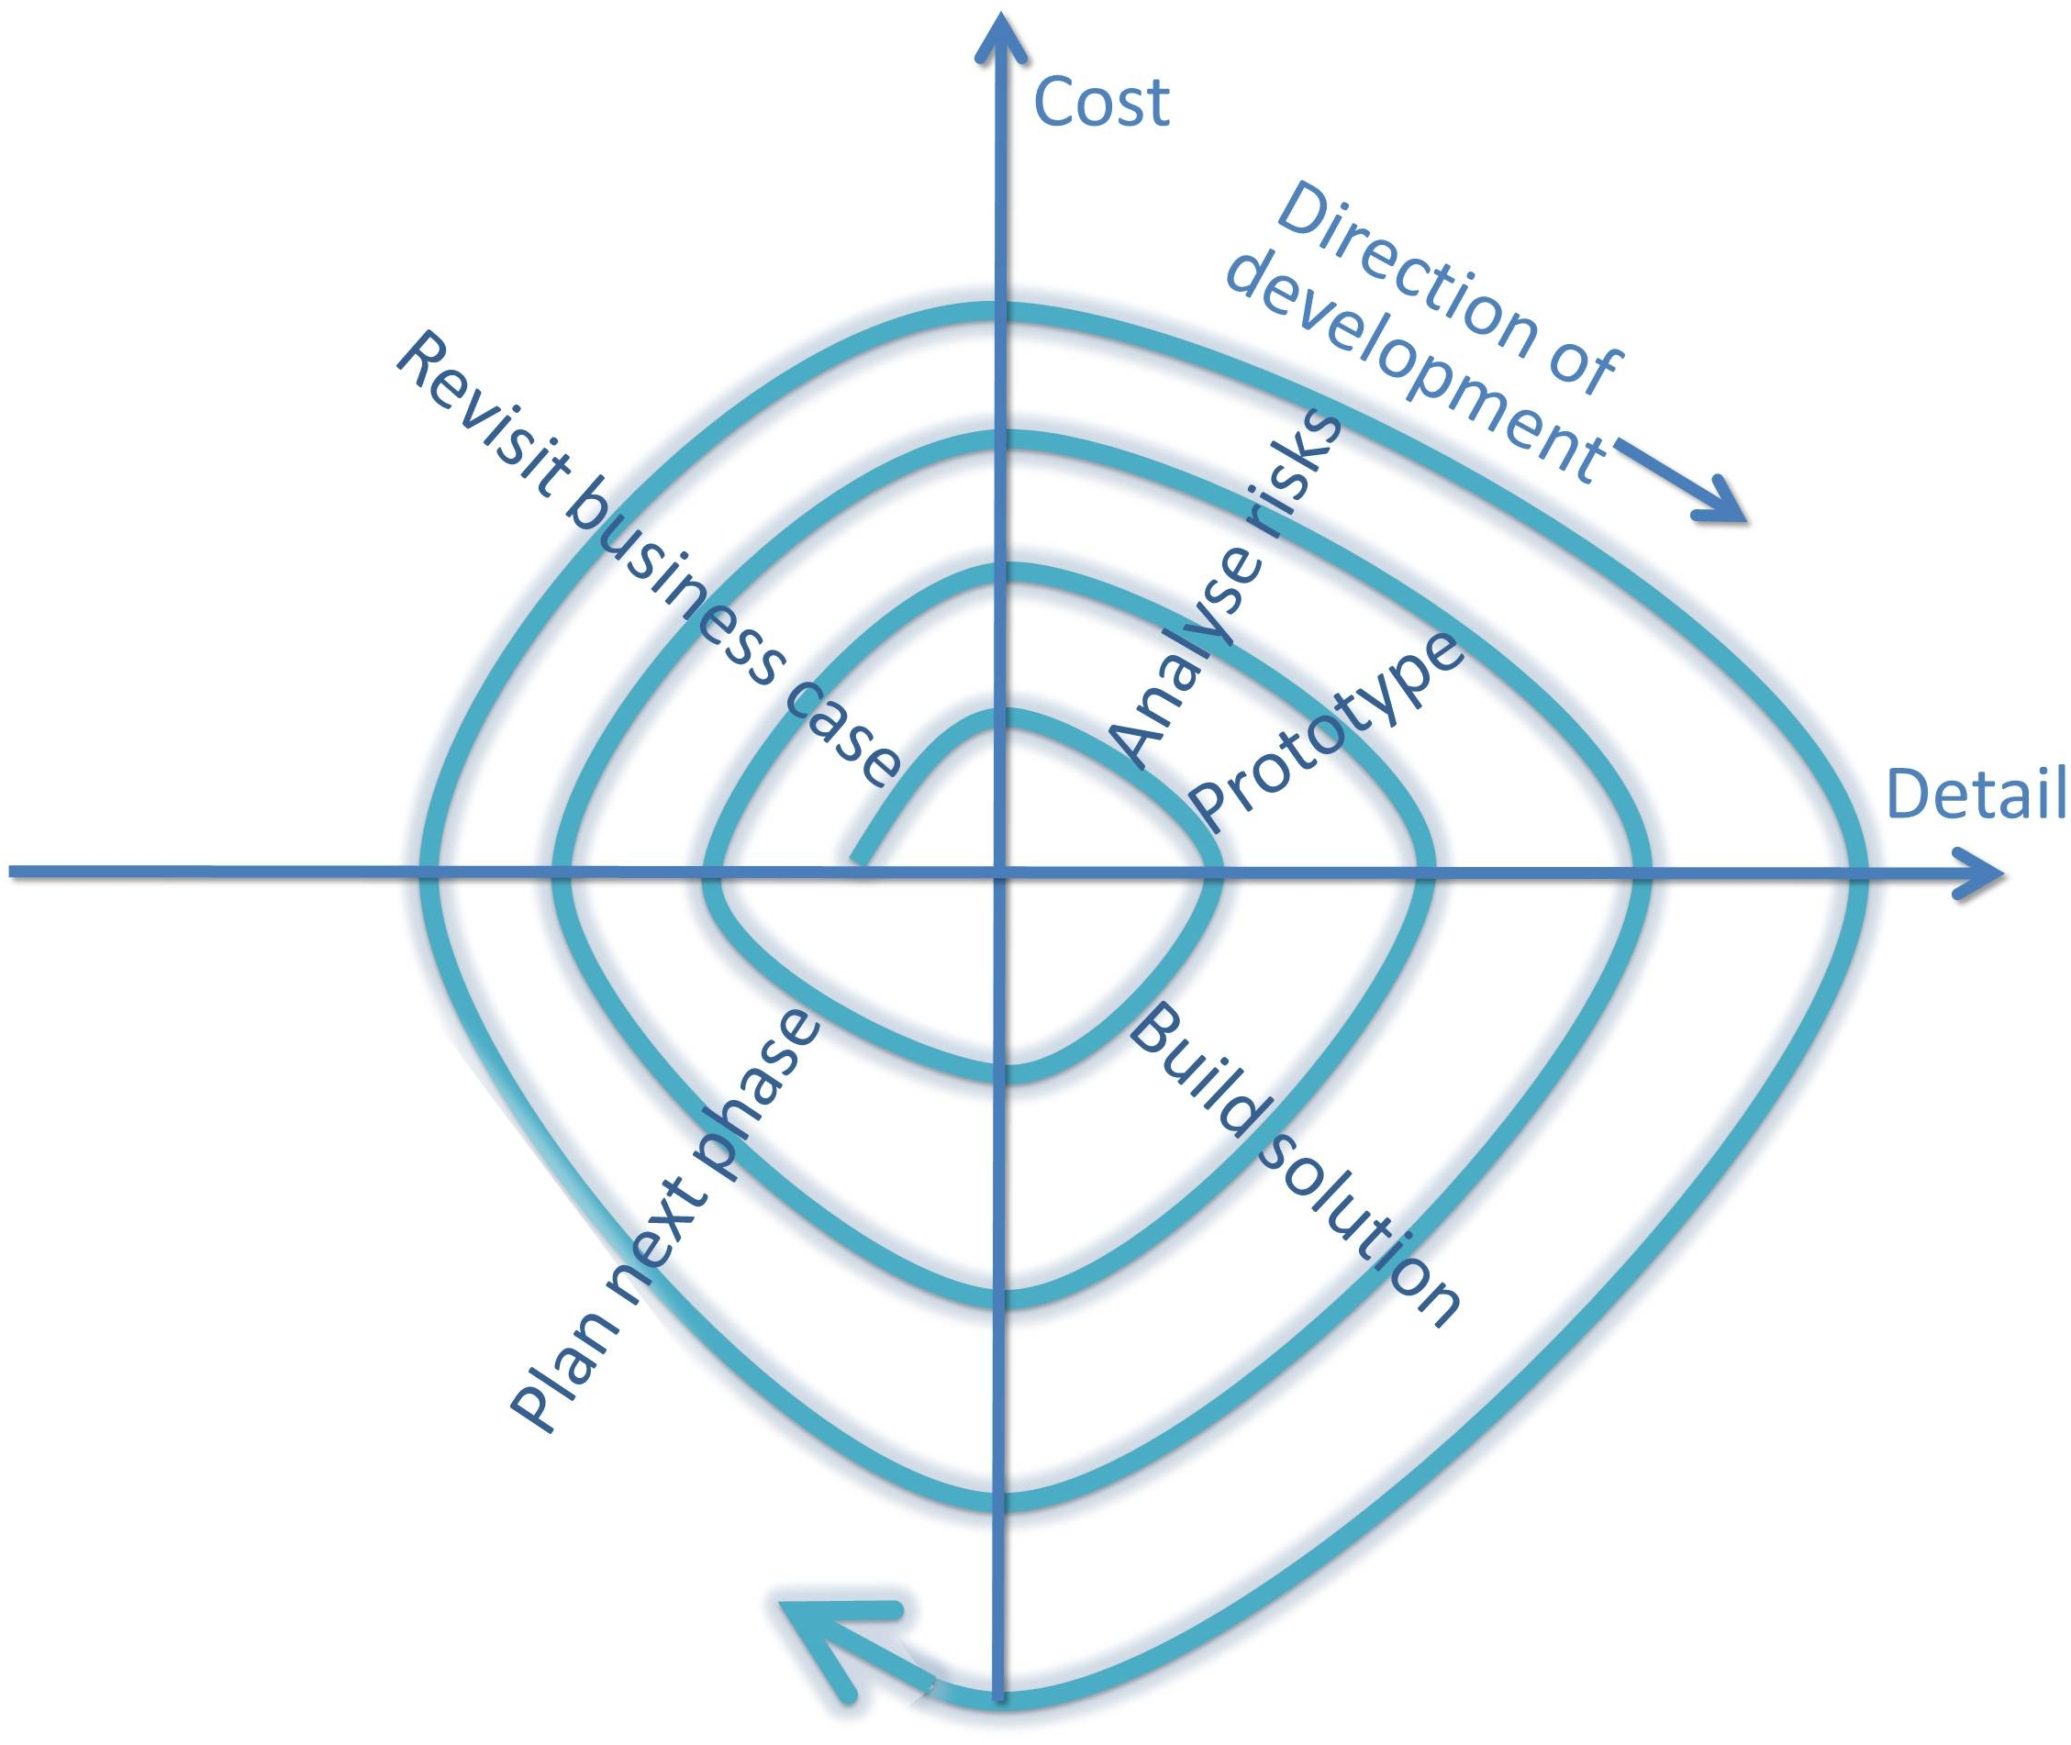

Figure 7: Spiral Model (adapted from Boehm 2001)[20]

Boehm identified six tests to ensure against “hazardous spiral lookalikes” and to keep the focus always on the customer. You can use these essential criteria to ensure success on your agile projects:[21]

* Spiral Essential One: Concurrent development should occur of theoperational concept, requirements, plans, design and solution. Boehm warns against adapting a sequential waterfall life cycle. He does identify limited conditions where waterfall may work. For example, if the requirements are pre-specifiable, slowly changing, and shared by all customers.
* Spiral Essential Two: The project should be disciplined in ensuring that objectives and constraints are reviewed by the customer at the end of every spiral (and therefore before the next spiral starts). Sufficient governance must be in place to ensure that alternatives are considered. The DOD must be vigilant against inertia and reaffirm a commitment to proceed at the end of each spiral. There is the risk that if any key stakeholders are excluded from technical discussions, or conversely that technicians are not sufficiently involved in risk analysis, then critical risks will go undetected, and unrealistic assumptions will go unchallenged.
* Spiral Essential 3: Effort in each spiral should be proportional to risk exposure. Risks can be generated by bad project decisions. Insufficient attention to this is called *project error risk*. Conversely, delays to delivery to the customer may occur by over-analyzing irrelevant items – this is *project delay risk*. As progress is made, the aim is to reduce overall risk, while optimizing the amount of time spent countering those risks. By definition, when the solution is implemented and is successfully deployed and producing benefits, then project risks have been reduced to zero, and what is left is the residual risk of ‘Business as Usual’ operations. If risks are badly managed then although the project may look like Spiral, problems will emerge. Incremental projects that follow this approach are termed *risk‑insensitive evolutionary developments*. An example of this is where detailed plans are produced for future spirals without any mechanism for modification after each round of risk review. If the DOD has insufficient linkage between risk management and project planning this symptom may occur.
* Spiral Essential 4: Detail of design and specification should be related to risk. The quality acceptance criteria should be only as detailed as necessary to address the risks of not doing so. Boehm points out that one should avoid assuming that a complete, consistent, traceable, testable requirements specification is always required. Too much BDUF increases the risk of delay by forcing solutions to conform to detailed requirements that eventually are discovered not to be what the customer wants. If there is evidence of BDUF in a project, then, Boehm argues, that project is not following a Spiral life cycle.
* Spiral Essential 5: Three essential *anchor point milestones* should exist in each spiral of a project at which the customer agrees project objectives, the project life cycle is agreed and the capability requirements are defined in overview. The three essential anchor point milestones are:
  + Life Cycle Objectives (LCO) Milestone where agreement on the viability of the next iteration of the solution is reviewed from a business perspective.
  + Life Cycle Approach (LCA) Milestone[22] where the project life cycle to be used is agreed and is linked to a risk-management plan. A decision must be made at each Spiral as to the nature of the development: evolutionary, incremental or even waterfall is appropriate. The LCA must be clear as to whether several spirals may exist between the anchor point milestones, and where in the spiral process they should sit. It must also ensure that evolutionary development is within the context of the many spirals that are required to produce a target solution. Boehm warns that there are risks in sub-optimization by targeting just the upcoming spiral, but storing up problems for the rest of the project.
  + Initial Operating Capability (IOC) Milestone where minimum operational requirements are agreed with the customer. By taking a minimalist approach, the dangers of too much analysis into non-critical requirements are avoided and stakeholder expectations are managed. [23]

Spiral Essential 6: A project should not ignore tasks that surround the development activities. We saw in Part I that there is evidence that the team developing the Education Benefits System at VA overlooked important implementation planning with the stakeholders, such as designing efficient operational procedures and training the users of the new technology. Teams working on technically intensive developments can fall into the trap of ignoring the whole life cycle, especially customer satisfaction. Non-functional requirements such as security, DOD‑5000 governance requirements, and special defense regulations must be taken into account in a holistic plan. The technical performance of the solution must be satisfactory within the actual operational environment, not just in the development lab. Business processes must be considered as must the need for planning organizational changes.

An example of the impact of DOD‑5000 and the potential for misinterpretation of the meaning of ‘Spiral’ development was provided in a Space and Missile Systems Center panel review in 2008. The National Security Space Acquisition Policy (NSSAP‑03‑01) had provided guidelines for implementation of DOD‑5000 for Milestone Decision Authorities (MDAs) for all DOD Space Major Defense Acquisition Programs. In this guidance a specific requirement was that the NSS acquisition team should be streamlined and ‘agile’, with “short, clear lines of authority with decision-making and program execution at the lowest levels possible”. However, a large project would still need detailed MDA approval and would not only be required to initiate a project in a waterfall fashion, but also would be required to revisit the MDA to changes required thereafter.[24]

Although Spiral Development was stated to be the key process, the definition of what is meant by the process remained open to interpretation. Definitions of what is meant by Spiral Development (SD) often simply refer back to the Defense Authorization Act of 2003. Peter Hantos warns that:

“A prevailing misconception is that (DOD‑5000 defines) spiral development, where concept development is the first spiral, technology development the second one, and system development and demonstration is the third one and so on.” [25]

This overlaying of a waterfall approach on top of the spiral life cycle, Hantos warns, is contrary to the concept of concurrent engineering and the risk-driven approach. Conventional risk management involves additional plans to attempt to drive out risk and the creation of alternative contingency plans. In Spiral development he points out, the key management actions are mitigation orientated. He concludes that the DOD policies are inherently waterfall in nature, even though they state the intent of being evolutionary.[26]

Efforts are continuing to try and make the DOD acquisitions process more incremental. Congress and DOD continue to try to reform the defense acquisition system. The Weapon Systems Acquisition Reform Act (2009) increased the regulation. It required more up-front engineering, cost estimating, and the development of more designs before starting system development. This type of regulation may simply entrench the belief that more and bigger specifications will reduce risk as in the past. This BDUF tendency is a key attribute of waterfall approaches, and often causes bad ideas to be baked into the project objectives right at the start.

The DOD has now instituted annual program reviews which will concentrate on proposing options for descoping and moderation of requirements. But these reforms are still uncertain, as the GAO recently noted.[27]

Evolutionary Acquisition and TSAT

In 2003 the GAO criticized the new $12bn Transformational Satellite (TSAT) project for starting development without detailed designs upfront. They said that more certainty was required of the technology and early designs before commitments were made. The concern was that commitment to TSAT would move funding away from another important program for high frequency satellites.[28]

The objective of TSAT was to enable DOD to enhance defense information collection – the first TSAT launch was planned for 2011. The GAO criticized the NSSAP‑03‑01 regulation for allowing the production to start while technology development was still ongoing. The GAO recommended that the DOD modify the policy to separate technology development from product development. The DOD disagreed, stating that the GAO’s recommendations would slow down acquisitions, increase risks, and prevent adoption of cutting edge technology.[29]

In April 2009 Robert Gates, the US Secretary of Defense, announced the termination of the program whose projected costs had risen from the original $12bn to $26bn. He announced the purchase of more Advanced Extremely High Frequency (AEHF) satellites instead, which had been proven in service.

He also cited problems with the VH-71 presidential helicopter project, which was six years behind schedule and had doubled in forecast cost to $13bn. The only viable solution from the program was for helicopters with a five- to 10-year useful life. He noted that the current VH-3 presidential helicopters were still in operation at 30 to 40 years of age. He stated:

“(We need) a fundamental overhaul of our approach to procurement, acquisition, and contracting … an acquisition system that can perform with greater urgency and agility … (the problem is that the) procurement and contracting cycle add layer upon layer of cost and complexity onto fewer and fewer platforms that take longer and longer to build”. [30]

The GAO proudly announced that as a result of its criticisms over the years of evolutionary projects, and the TSAT project in particular, it had saved the taxpayer $5.3bn by informing Secretary Gates’s decision.[31] But, in an analysis of NSSAP‑03‑01 to instruction DOD‑5000, Mark Lorell, in a Rand Corporation research paper, argues that although the system design review and preliminary design review milestones come earlier in NSSAP‑03‑01, there are no other significant differences.[32]

Conflicting guidance is one of the biggest inhibitors to agile adoption, and creates a variety of standards against which audit bodies can criticize the approaches taken. Often it is a case of being *damned if you do, and being damned if you don’t*.

The OMB Capital Programming Guide, for example, recommends both incrementalism and BDUF, two concepts that are difficult to reconcile. In some places the guide recommends flexibility and modularity and minimal statement of core requirements.

On the one hand, the Guide says that only once a solution meets core requirements should additional functionality be added. Modular or spiral development should be pursued where possible, and is a ‘best practice’. Performance of the solution, it says, should be the objective, not a detailed design specification, and projects should use rapid prototyping techniques.[33]

On the other hand, the Guide emphasizes the importance of detailed planning upfront, and the need for detailed requirements to be defined before starting to draw up a well-developed breakdown of tasks (WBS) which should be used to track the detail and cost of each small task performed.[34]

As mentioned previously, the OMB has specific responsibilities for managing the risks of major information systems initiatives, and has required each federal agency to appoint a Chief Information Officer (CIO) to manage IT investment projects. When the OMB was given this responsibility in 2008, it took on the job of closely monitoring a *watch list* of 413 projects, 352 of which were poorly performing and an additional 61 that seemed to be running well, but were at very high risk of failure. The total value of these projects was a staggering $25.2bn, with 48% having made major changes to their agreed baseline objectives and plans which increased costs. 11% had been identified as grossly overrunning, but the worry was that this was only the tip of an ‘iceberg’, and that many problems lay hidden.

The GAO’s conclusion was not that a different approach was needed, but that even more planning was required.[35]The OMB recognized that agile projects could be considered as being ‘well-run’ and they included a small dispensation for detailed up-front planning for modular projects with rapid prototyping techniques and incremental development.[36]

But the emphasis here by both the OMB and the GAO was on detailed cost assessment and low-level monitoring of every task to ensure that no-one deviated from an up-front plan – the opposite of an agile approach.[37] Each performance measurement baseline is based on an early, detailed breakdown of project activities. These are then closely tracked using EVA to add up the cost of every task carried out and compare it to the original estimate. A deviation of more than 10% from the initial plan is seen as project failure, not a failure in the theoretical estimates, and usually not taken as an opportunity to change direction or scope.[38]

A change of approach, though, is underway. The President’s eGovernment scorecard, a measure previously used to track quality of IT projects, has been discontinued. It valued the collection and adherence to detailed planning and collection of accurate project progress metrics above customer satisfaction or early delivery. The OMB criticized this approach because, it said, it rewarded excellent documentation and detailed plans over the actual realization of business benefits. Flexibility and rebaselining were seen merely as mechanisms which were potentially being used *“to mask cost overruns and schedule delays”.*[39] 85% of projects that were added to the watch list were added because they fell outside tight parameters for documentation and budget management. The process was of little use because it did not pin-point the key problem projects. The OMB could not follow up so many problems as its predominant mission was to prepare the federal budgets rather than identify the risks of individual project failures.[40]

However, the relationship between poor performance as measured by project objectives and what the scorecard approach defined as ‘poor planning’ was unclear. In 2008, the GAO found that 326 projects had ‘poor planning’ but were not assessed as high risk or poorly performing. Conversely, 61 projects had been identified as poorly performing but well planned.[41]

Many projects at the Department of Homeland Security, for example, had made substantial incremental delivery in many of their projects. One project that was criticized was the successful incremental deployment of the Rescue 21 coastguard search and rescue system. The US-VISIT program was criticized despite the implementation of biometrically enabled entry capabilities at 300 air, sea, and land points of entry. The GAO criticized that project not for lack of implementation, but for lacking a “conceptual solution architecture” and for not having followed a waterfall life cycle.[42] It was only in 2010 that the OMB made a clear statement that:

“Many projects use ‘grand design’ approaches that aim to deliver functionality every few years, rather than breaking projects into more manageable chunks and demanding new functionality every few quarters … (the Government should) only approve funding of major IT programs that … use a modular approach with usable functionality delivered every six months.” [43]

Criticisms of Current Approaches in the USA and UK

The USA and UK have both announced major changes in their approach to major projects of work, especially where those projects depend largely on technology and IT solutions.

Although there is recognition of the advantages of an agile approach for incremental development and deployment, the need for leadership by top management is not stressed, and too much emphasis is still placed by those responsible for assurance and audit on compliance to BDUF standards. Agile government needs to be seamlessly implemented by leadership of management and technical experts. Process and standards cannot be a substitute for good decision-making, especially when projects are at critical points and need clear objectives and priorities.

For example, the OMB’s 25 Point Implementation Plan specifies that a modular approach is expected of projects “with usable functionality delivered every six months”, but fails to make clear that the focus should be on delivery of early business benefits, not just delivery for its own sake. Tough decisions need to be made by top management when prioritizing, and if necessary, less important content should be removed from scope so as to focus on meeting 100% of deadlines rather than 100% of the initial specification.[44]

The 25 Point Plan identifies that IT acquisition practices are not currently effective. The only specific guidance on how they should be improved is a recommendation for more ‘best practice’ guidance.[45] It misses an opportunity to stress the risks of waterfall procurement milestones and big-bang implementation, and to ensure a presumption against big-bang procurements in favor of incremental delivery and implementation with commensurate milestones.

Similarly, the OPM has released a model set of competencies to improve IT program management in Government and develop an IT program management career path. The competencies need to reflect more the debate and wide acceptance of agile project management for technology development. The overriding importance of achieving benefits from projects, not just delivering outputs, needs more emphasis. Benefits realization planning is a cornerstone of agile thinking (see Agile Leadership Behavior One). Customer satisfaction comes first and foremost. IT project managers need to focus on early piloting, phasing of implementation, and planning the measurement of the improvement of performance of operations. Baseline business performance must be measured and compared with actual results from each increment of project delivery so as to feedback and modify the project approach and objectives in the light of experience.[46]

The OPM competency framework requires knowledge of ‘the project life cycle’, which it defines as starting with planning and development and moving on to implementation in a later phase. This could be read to imply discrete, sequential phases – in other words a regression in thinking to waterfall life cycle concepts.[47] In contrast, as I mentioned in the Introduction, from 2014 New Zealand will be turning out IT workers for the future that have been introduced to agile concepts by practical use of iterative development in high-school classrooms.[48]

In the UK the Treasury guidance on ‘Managing Public Money’ is still the reference work with which all senior civil servants must comply when spending money on projects. The importance of the use of incremental development techniques and phased delivery to provide feedback and steer project strategy is not mentioned, despite these having been identified by the UK Government as some of the main reasons for project failures. The factors listed to consider when planning policies or projects assume that ‘full roll-out’ is the default option, with an implication that pilot testing is optional in most cases.[49] The guidance should require that attention is spent on breaking development and implementation into manageable steps and phasing implementation so as to bring early benefits. An opportunity has been missed in this strategic regulatory document to reflect the advice elsewhere in more detailed documentation that big-bang implementation is not the default option that is usually to be preferred. ‘Full rollout’ in a single phase should be assessed as a counter-factual alternative to incremental piloting and phased rollout in the ‘Green Book Business Case’ required for each project.

Conclusions

The first Agile Leadership Behavior ensures that the customer is at the center of the project. Delivering *outputs* is the short-term focus, but the real mission is improving the business *outcome*s.

The Lockheed Martin F/A-22 ‘Raptor’ strike aircraft project was a big-bangproject where the customer was told to wait for years to see any outputs. The project was one of many failures which prompted the US Department of Defense to encourage *evolutionary* projects with the customer closely involved in incremental development of a solution.

In both the UK and the US there continues to be conflicting guidance, despite the declared policy for incremental and evolutionaryapproaches to projects. The GAO and the NAO need to refine their guidance and auditing approach (see Part III).

Barry Boehm’s Spiral approach is one incremental approach which can support an agile project. Use Boehm’s six essential tests to ensure that your project really is agile. Agile project management in the US Government is spreading quickly, but only has tentative and lukewarm adoption in the UK.

The US Government has changed its culture by direct intervention from a strong Government Chief Information Officer (CIO) and produced several large, high profile agile success stories in a short space of time. The UK has decided on a collegiate approach and has yet to deliver its first large-scale agile project. Although there are some promising pockets of excellence emerging, only about half of the UK Government departments have any agile projects, and most of these are very small-scale.

1. {B.W. Boehm 1989 #202}
2. {US Public Law 2002 #379}
3. {Williams 2012 #239}
4. Comparing {Schwaber 25/03/2010 #117} to {Schwaber July 2011 #118} and {Sutherland 2007 #119}. The word ‘software’ was used 339 times in the 2007 version, only six times in the 2010 version and zero times in the 2011 version.
5. {Aviation Week 2011 #122}
6. {NAO 2006 #391: 8}
7. {NAO 2006 #391: 8}
8. {National Audit Office report HC 2006 #150: 50}
9. {National Audit Office report HC 2006 #150: 49}
10. {Treasury 01/11/2005 #149: 29}
11. {GAO 2003 #121}
12. {HM Treasury and Cabinet Office April 2011 #25: Table 3.C}
13. {UK – Cabinet Office 2011 #153: 6}
14. {National Audit Office report HC 2006 #150: 35}
15. {U.S. Government Accountability Office 2009 #154: 10}
16. {U.S. Government Accountability Office 01/02/2010 #155: 78}
17. {Federal CIO pursues relentless efficiency #331}
18. {Kundra 2010 #333}
19. {USD(AT&L) 24/01/2008 #199}
20. {Boehm 2001 #198}
21. {Boehm 2001 #198}
22. Note: Rather confusingly, Boehm uses the term ‘architecture’. I have changed this to “approach” because LCA does not relate to a technical architecture, but to the “architecture” of the project processes.
23. {Boehm 2001 #198: 7}
24. {Teets 2003 #339}
25. {Hantos 2008 #338: 27}
26. {Hantos 2008 #338: 29}
27. {GAO 2012 #345: 20}
28. {Levin 2003 #341}
29. {GAO 2003 #342}
30. {Gates April 2009 #343}
31. {U.S. Government Accountability Office #344: 11}
32. {Lorell 2006 #340: 35–36}
33. {Ewell 2006 #159: 11, 34, 38, 101, Appendix 12}
34. {Ewell 2006 #159: 10, 12, 71, Appendix 3}
35. {US Government Accountability Office 2008 #156}
36. {Ewell 2006 #159}
37. {Ewell 2006 #159: 71, Appendix 3}
38. {US DOD 2003 #163}
39. {OMB 18/04/2003 #160: 20}
40. {U.S. Government Accountability Office 15/04/2005 #161: 9 and 13}
41. {US Government Accountability Office 2008 #156: 11}
42. {U.S. Government Accountability Office 2009 #164: 17}
43. {Kundra 2010 #157: 1}
44. {Kundra 2010 #157: Introduction}
45. {Kundra 2010 #157: 14}
46. {OGC 2011 #205}
47. {Berry Dec 2011 #162}
48. {Bell 2010 #260} and {Dinning 2009 #261}
49. {Treasury 01/11/2005 #149: 29 and Boxes 4.2 and 4.7}